[](https://www.comsol.com/)

ES607- Project III GP II Study CD v Low Re

|  |  |
| --- | --- |
| Report date | Nov 24, 2024 6:29:49 AM |

Contents

1. Global Definitions

1.1. Parameters

2. Component 1

2.1. Definitions

2.2. Geometry 1

2.3. Laminar Flow

2.4. Mesh 1

3. Study 1

3.1. Stationary

3.2. Solver Configurations

4. Results

4.1. Datasets

4.2. Derived Values

4.3. Tables

4.4. Plot Groups

1. Global Definitions

|  |  |
| --- | --- |
| Date | Nov 21, 2024 3:55:18 PM |

Global settings

|  |  |
| --- | --- |
| Name | ES607- Project III GP II Study CD v Low Re.mph |
| Path | C:\Users\mayan\Downloads\ES607- Project III GP II Study CD v Low Re.mph |
| Version | COMSOL Multiphysics 5.6 (Build: 401) |
| Unit system | None |

Used products

|  |
| --- |
| COMSOL Multiphysics |

Computer information

|  |  |
| --- | --- |
| CPU | AMD64 Family 23 Model 104 Stepping 1, 6 cores |
| Operating system | Windows 10 |

* 1. Parameters

Parameters 1

| **Name** | **Expression** | **Value** | **Description** |
| --- | --- | --- | --- |
| H | 50 | 50 |  |
| W | 70 | 70 |  |
| Re | 0.01 | 0.01 |  |

1. Component 1

|  |  |
| --- | --- |
| Date | Nov 21, 2024 2:11:52 PM |

Settings

| **Description** | **Value** |
| --- | --- |
| Unit system | Same as global system (None) |
| Geometry shape function | Automatic |

Spatial frame coordinates

| **First** | **Second** | **Third** |
| --- | --- | --- |
| r | phi | z |

Material frame coordinates

| **First** | **Second** | **Third** |
| --- | --- | --- |
| R | PHI | Z |

Geometry frame coordinates

| **First** | **Second** | **Third** |
| --- | --- | --- |
| Rg | PHIg | Zg |

Mesh frame coordinates

| **First** | **Second** | **Third** |
| --- | --- | --- |
| Rm | PHIm | Zm |

* 1. Definitions
     1. Nonlocal Couplings

#### Integration 1

|  |  |
| --- | --- |
| Coupling type | Integration |
| Operator name | intop1 |

Selection

|  |  |
| --- | --- |
| Geometric entity level | Boundary |
| Selection | Geometry geom1: Dimension 1: Boundaries 8–9 |

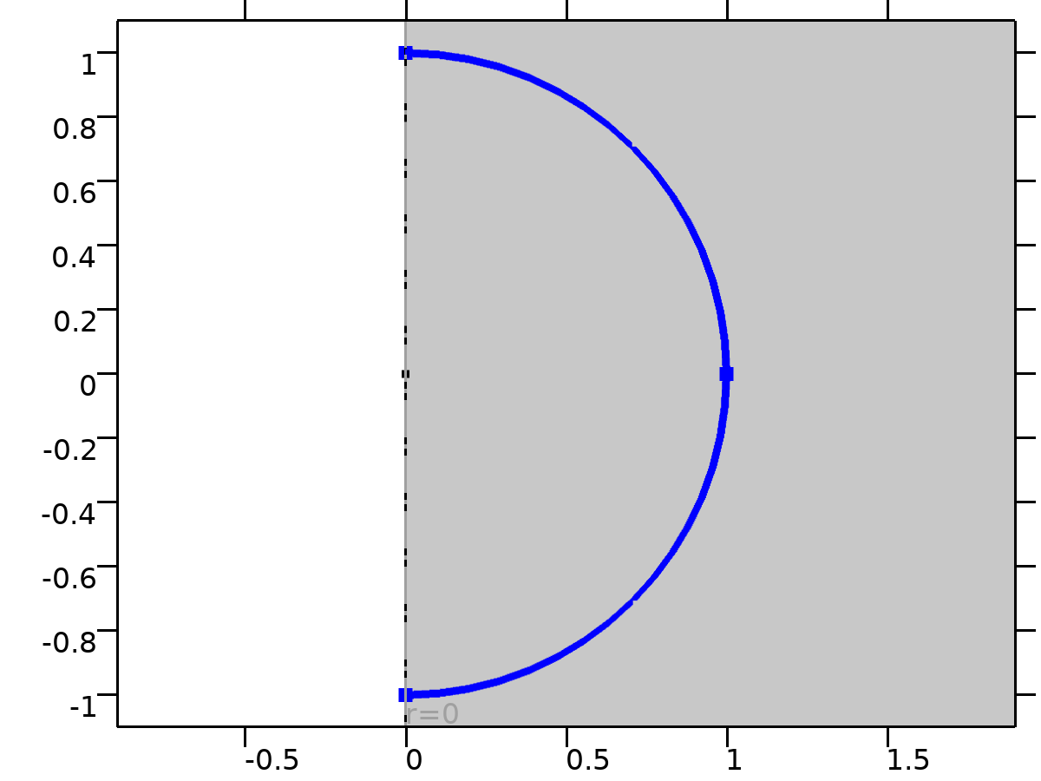

Selection

Advanced

| **Description** | **Value** |
| --- | --- |
| Compute integral in revolved geometry | On |

* + 1. Coordinate Systems

#### Boundary System 1

|  |  |
| --- | --- |
| Coordinate system type | Boundary system |
| Tag | sys1 |

Coordinate names

| **First** | **Second** | **Third** |
| --- | --- | --- |
| t1 | to | n |

* 1. Geometry 1

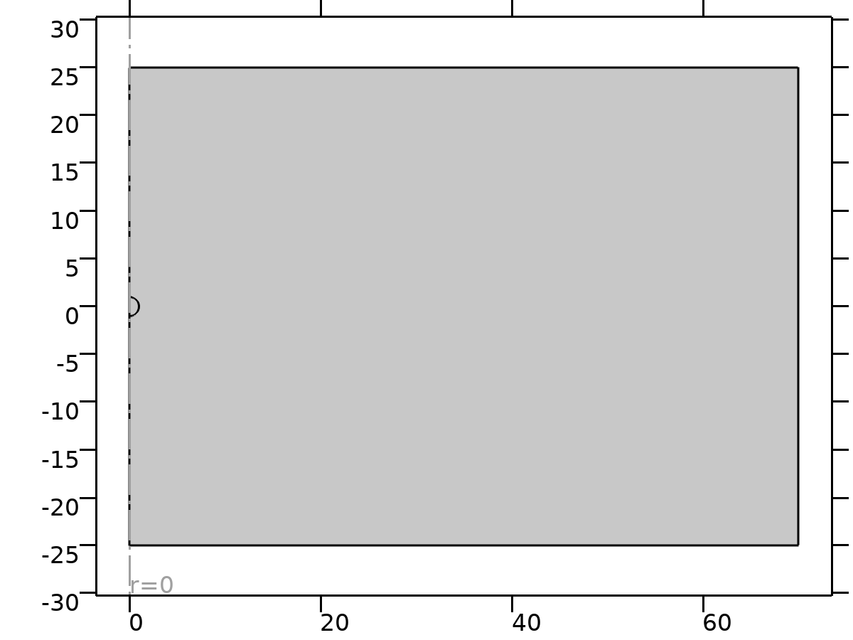

Geometry 1

Geometry statistics

| **Description** | **Value** |
| --- | --- |
| Space dimension | 2 |
| Number of domains | 2 |
| Number of boundaries | 9 |
| Number of vertices | 8 |

* + 1. Circle 1 (c1)

Position

| **Description** | **Value** |
| --- | --- |
| Position | {0, 0} |

Rotation angle

| **Description** | **Value** |
| --- | --- |
| Rotation | -90 |

Size and shape

| **Description** | **Value** |
| --- | --- |
| Radius | 1 |
| Sector angle | 180 |

* + 1. Rectangle 1 (r1)

Position

| **Description** | **Value** |
| --- | --- |
| Position | {0, -H/2} |

Size

| **Description** | **Value** |
| --- | --- |
| Width | W |
| Height | H |

* + 1. Rectangle 2 (r2)

Position

| **Description** | **Value** |
| --- | --- |
| Position | {0, -H/2} |

Size

| **Description** | **Value** |
| --- | --- |
| Width | 5 |
| Height | H |

* 1. Laminar Flow

Used products

|  |
| --- |
| COMSOL Multiphysics |

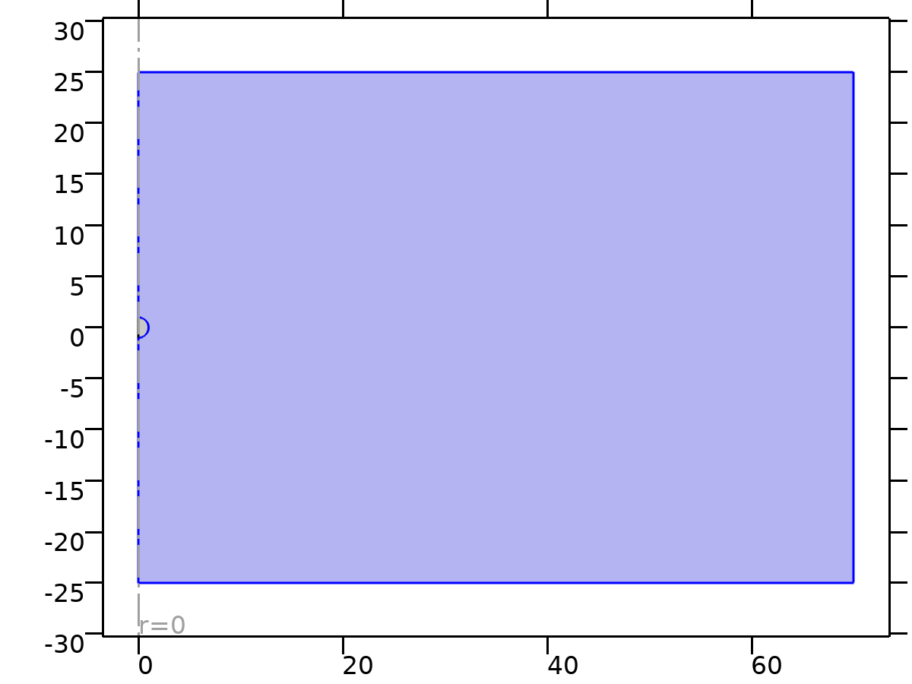

Laminar Flow

Selection

|  |  |
| --- | --- |
| Geometric entity level | Domain |
| Selection | Geometry geom1: Dimension 2: Domain 1 |

Equations





* + 1. Interface Settings

#### Discretization

Settings

| **Description** | **Value** |
| --- | --- |
| Discretization of fluids | P1 + P1 |

#### Physical Model

Settings

| **Description** | **Value** |
| --- | --- |
| Neglect inertial term (Stokes flow) | Off |
| Compressibility | Incompressible flow |
| Swirl flow | Off |
| Enable porous media domains | Off |
| Include gravity | Off |
| Reference temperature | User defined |
| Reference temperature | 293.15[K] |
| Reference pressure level | 1[atm] |

#### Turbulence

Settings

| **Description** | **Value** |
| --- | --- |
| Turbulence model type | None |

* + 1. Variables

| **Name** | **Expression** | **Description** | **Selection** | **Details** |
| --- | --- | --- | --- | --- |
| spf.Tref | model.input.Tref | Reference temperature | Global | Meta |
| spf.dz | 1 | Thickness | Domain 1 |  |
| spf.pref | 1[atm] | Reference pressure level | Domain 1 |  |
| spf.pA | p+spf.pref | Absolute pressure | Domain 1 |  |
| spf.hasWF | 0 | Help variable | Boundaries 1–2, 5–9 |  |
| spf.dt_CFL | 1/max(spf.maxop(sqrt(emetric_spatial(u-d(r,TIME),w-d(z,TIME)))),eps) | Time step, CFL=1 | Global |  |
| spf.Qvd_tot | spf.intop(2*spf.Qvd*pi*r) | Total viscous dissipation | Global |  |
| spf.K_stressr | spf.K_stress_tensorrr*spf.nrmesh+spf.K_stress_tensorrphi*spf.nphimesh+spf.K_stress_tensorrz*spf.nzmesh | Viscous force, exterior boundaries, r component | Boundaries 1–2, 5–9 |  |
| spf.K_stressphi | spf.K_stress_tensorphir*spf.nrmesh+spf.K_stress_tensorphiphi*spf.nphimesh+spf.K_stress_tensorphiz*spf.nzmesh | Viscous force, exterior boundaries, phi component | Boundaries 1–2, 5–9 |  |
| spf.K_stressz | spf.K_stress_tensorzr*spf.nrmesh+spf.K_stress_tensorzphi*spf.nphimesh+spf.K_stress_tensorzz*spf.nzmesh | Viscous force, exterior boundaries, z component | Boundaries 1–2, 5–9 |  |
| spf.T_stressr | spf.T_stress_tensorrr*spf.nrmesh+spf.T_stress_tensorrphi*spf.nphimesh+spf.T_stress_tensorrz*spf.nzmesh | Total traction, exterior boundaries, r component | Boundaries 1–2, 5–9 |  |
| spf.T_stressphi | spf.T_stress_tensorphir*spf.nrmesh+spf.T_stress_tensorphiphi*spf.nphimesh+spf.T_stress_tensorphiz*spf.nzmesh | Total traction, exterior boundaries, phi component | Boundaries 1–2, 5–9 |  |
| spf.T_stressz | spf.T_stress_tensorzr*spf.nrmesh+spf.T_stress_tensorzphi*spf.nphimesh+spf.T_stress_tensorzz*spf.nzmesh | Total traction, exterior boundaries, z component | Boundaries 1–2, 5–9 |  |
| spf.K_stress_dr | down(spf.K_stress_tensorrr)*spf.dnrmesh+down(spf.K_stress_tensorrphi)*spf.dnphimesh+down(spf.K_stress_tensorrz)*spf.dnzmesh | Viscous force, interior boundaries, downside, r component | Boundaries 1–2, 5–7 |  |
| spf.K_stress_dphi | down(spf.K_stress_tensorphir)*spf.dnrmesh+down(spf.K_stress_tensorphiphi)*spf.dnphimesh+down(spf.K_stress_tensorphiz)*spf.dnzmesh | Viscous force, interior boundaries, downside, phi component | Boundaries 1–2, 5–7 |  |
| spf.K_stress_dz | down(spf.K_stress_tensorzr)*spf.dnrmesh+down(spf.K_stress_tensorzphi)*spf.dnphimesh+down(spf.K_stress_tensorzz)*spf.dnzmesh | Viscous force, interior boundaries, downside, z component | Boundaries 1–2, 5–7 |  |
| spf.K_stress_ur | up(spf.K_stress_tensorrr)*spf.unrmesh+up(spf.K_stress_tensorrphi)*spf.unphimesh+up(spf.K_stress_tensorrz)*spf.unzmesh | Viscous force, interior boundaries, upside, r component | Boundaries 8–9 |  |
| spf.K_stress_uphi | up(spf.K_stress_tensorphir)*spf.unrmesh+up(spf.K_stress_tensorphiphi)*spf.unphimesh+up(spf.K_stress_tensorphiz)*spf.unzmesh | Viscous force, interior boundaries, upside, phi component | Boundaries 8–9 |  |
| spf.K_stress_uz | up(spf.K_stress_tensorzr)*spf.unrmesh+up(spf.K_stress_tensorzphi)*spf.unphimesh+up(spf.K_stress_tensorzz)*spf.unzmesh | Viscous force, interior boundaries, upside, z component | Boundaries 8–9 |  |
| spf.T_stress_dr | down(spf.T_stress_tensorrr)*spf.dnrmesh+down(spf.T_stress_tensorrphi)*spf.dnphimesh+down(spf.T_stress_tensorrz)*spf.dnzmesh | Total traction, interior boundaries, downside, r component | Boundaries 1–2, 5–7 |  |
| spf.T_stress_dphi | down(spf.T_stress_tensorphir)*spf.dnrmesh+down(spf.T_stress_tensorphiphi)*spf.dnphimesh+down(spf.T_stress_tensorphiz)*spf.dnzmesh | Total traction, interior boundaries, downside, phi component | Boundaries 1–2, 5–7 |  |
| spf.T_stress_dz | down(spf.T_stress_tensorzr)*spf.dnrmesh+down(spf.T_stress_tensorzphi)*spf.dnphimesh+down(spf.T_stress_tensorzz)*spf.dnzmesh | Total traction, interior boundaries, downside, z component | Boundaries 1–2, 5–7 |  |
| spf.T_stress_ur | up(spf.T_stress_tensorrr)*spf.unrmesh+up(spf.T_stress_tensorrphi)*spf.unphimesh+up(spf.T_stress_tensorrz)*spf.unzmesh | Total traction, interior boundaries, upside, r component | Boundaries 8–9 |  |
| spf.T_stress_uphi | up(spf.T_stress_tensorphir)*spf.unrmesh+up(spf.T_stress_tensorphiphi)*spf.unphimesh+up(spf.T_stress_tensorphiz)*spf.unzmesh | Total traction, interior boundaries, upside, phi component | Boundaries 8–9 |  |
| spf.T_stress_uz | up(spf.T_stress_tensorzr)*spf.unrmesh+up(spf.T_stress_tensorzphi)*spf.unphimesh+up(spf.T_stress_tensorzz)*spf.unzmesh | Total traction, interior boundaries, upside, z component | Boundaries 8–9 |  |
| spf.usePseudoTimeStepping | 0 | Help variable | Global | + operation |
| spf.localCFLvalue | 1.3^min(niterCMP,9)+if(niterCMP>=25,9*1.3^min(-25+niterCMP,9),0)+if(niterCMP>=45,90*1.3^min(-45+niterCMP,9),0) | Local CFL number | Domain 1 |  |
| spf.locCFL | CFLCMP | Local CFL number | Domain 1 |  |
| spf.geometryLengthScale | 12.5 | Geometry length scale | Domain 1 |  |
| spf.time_step_inv | max(sqrt(emetric_spatial(u,w)*2^gmg_level^2),spf.nu/spf.geometryLengthScale^2) | Inverse time step | Domain 1 |  |
| spf.tsti | nojac(spf.time_step_inv/spf.locCFL) | Help variable | Domain 1 |  |
| spf.nr | unr | Normal vector, r component | Boundaries 8–9 |  |
| spf.nphi | 0 | Normal vector, phi component | Boundaries 8–9 |  |
| spf.nz | unz | Normal vector, z component | Boundaries 8–9 |  |
| spf.nr | dnr | Normal vector, r component | Boundaries 1–2, 5–7 |  |
| spf.nphi | 0 | Normal vector, phi component | Boundaries 1–2, 5–7 |  |
| spf.nz | dnz | Normal vector, z component | Boundaries 1–2, 5–7 |  |
| spf.nrmesh | unrmesh | Normal vector, r component | Boundaries 8–9 |  |
| spf.nphimesh | 0 | Normal vector, phi component | Boundaries 8–9 |  |
| spf.nzmesh | unzmesh | Normal vector, z component | Boundaries 8–9 |  |
| spf.nrmesh | dnrmesh | Normal vector, r component | Boundaries 1–2, 5–7 |  |
| spf.nphimesh | 0 | Normal vector, phi component | Boundaries 1–2, 5–7 |  |
| spf.nzmesh | dnzmesh | Normal vector, z component | Boundaries 1–2, 5–7 |  |

* + 1. Fluid Properties 1



Fluid Properties 1

Selection

|  |  |
| --- | --- |
| Geometric entity level | Domain |
| Selection | Geometry geom1: Dimension 2: All domains |

Equations

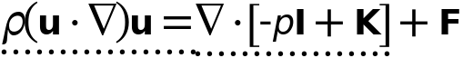



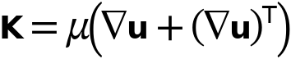

#### Fluid Properties

Settings

| **Description** | **Value** |
| --- | --- |
| Density | User defined |
| Density | Re |
|  | Newtonian |
| Dynamic viscosity | User defined |
| Dynamic viscosity | 1 |

#### Variables

| **Name** | **Expression** | **Description** | **Selection** | **Details** |
| --- | --- | --- | --- | --- |
| spf.mu | material.mu | Dynamic viscosity | Domain 1 | Meta |
| spf.rho | material.rho | Density | Domain 1 | Meta |
| spf.Trho | spf.fp1.minput_temperature | Temperature for density evaluation | Domain 1 |  |
| spf.prho | spf.fp1.minput_pressure | Pressure for the evaluation of density | Domain 1 |  |
| spf.rhoref | subst(material.rho,minput.T,spf.Tref,minput.pA,spf.pref) | Reference density | Domain 1 | Meta |
| spf.mumat | material.mu | Dynamic viscosity | Domain 1 | Meta |
| spf.srijrr | ur | Strain rate tensor, rr component | Domain 1 |  |
| spf.srijphir | 0 | Strain rate tensor, phir component | Domain 1 |  |
| spf.srijzr | 0.5*(wr+uz) | Strain rate tensor, zr component | Domain 1 |  |
| spf.srijrphi | 0 | Strain rate tensor, rphi component | Domain 1 |  |
| spf.srijphiphi | if(abs(r)<0.001*h_spatial,ur,u/r) | Strain rate tensor, phiphi component | Domain 1 |  |
| spf.srijzphi | 0 | Strain rate tensor, zphi component | Domain 1 |  |
| spf.srijrz | 0.5*(uz+wr) | Strain rate tensor, rz component | Domain 1 |  |
| spf.srijphiz | 0 | Strain rate tensor, phiz component | Domain 1 |  |
| spf.srijzz | wz | Strain rate tensor, zz component | Domain 1 |  |
| spf.rrijrr | 0 | Rotation rate tensor, rr component | Domain 1 |  |
| spf.rrijphir | 0 | Rotation rate tensor, phir component | Domain 1 |  |
| spf.rrijzr | 0.5*(wr-uz) | Rotation rate tensor, zr component | Domain 1 |  |
| spf.rrijrphi | 0 | Rotation rate tensor, rphi component | Domain 1 |  |
| spf.rrijphiphi | 0 | Rotation rate tensor, phiphi component | Domain 1 |  |
| spf.rrijzphi | 0 | Rotation rate tensor, zphi component | Domain 1 |  |
| spf.rrijrz | 0.5*(uz-wr) | Rotation rate tensor, rz component | Domain 1 |  |
| spf.rrijphiz | 0 | Rotation rate tensor, phiz component | Domain 1 |  |
| spf.rrijzz | 0 | Rotation rate tensor, zz component | Domain 1 |  |
| spf.sr | sqrt(2*spf.srijrr^2+2*spf.srijrphi^2+2*spf.srijrz^2+2*spf.srijphir^2+2*spf.srijphiphi^2+2*spf.srijphiz^2+2*spf.srijzr^2+2*spf.srijzphi^2+2*spf.srijzz^2+eps) | Shear rate | Domain 1 |  |
| spf.rr | sqrt(2*spf.rrijrr^2+2*spf.rrijrphi^2+2*spf.rrijrz^2+2*spf.rrijphir^2+2*spf.rrijphiphi^2+2*spf.rrijphiz^2+2*spf.rrijzr^2+2*spf.rrijzphi^2+2*spf.rrijzz^2+eps) | Rotation rate | Domain 1 |  |
| spf.divu | ur+if(abs(r)<0.001*h_spatial,ur,u/r)+wz | Divergence of velocity field | Domain 1 |  |
| spf.Fr | 0 | Volume force, r component | Domain 1 | + operation |
| spf.Fphi | 0 | Volume force, phi component | Domain 1 | + operation |
| spf.Fz | 0 | Volume force, z component | Domain 1 | + operation |
| spf.U | sqrt(u^2+w^2) | Velocity magnitude | Domain 1 |  |
| spf.vorticityr | 0 | Vorticity field, r component | Domain 1 |  |
| spf.vorticityphi | -wr+uz | Vorticity field, phi component | Domain 1 |  |
| spf.vorticityz | 0 | Vorticity field, z component | Domain 1 |  |
| spf.vort_magn | sqrt(spf.vorticityr^2+spf.vorticityphi^2+spf.vorticityz^2) | Vorticity magnitude | Domain 1 |  |
| spf.cellRe | 0.25*spf.rho*sqrt(emetric_spatial(u-d(r,TIME),w-d(z,TIME))/emetric2_spatial)/spf.mu | Cell Reynolds number | Domain 1 |  |
| spf.nu | spf.mu/spf.rho | Kinematic viscosity | Domain 1 |  |
| spf.betaT | 0 | Isothermal compressibility coefficient | Domain 1 |  |
| spf.Qm | 0 | Source term | Domain 1 | + operation |
| spf.Fgtotr | 0 | Gravity force, r component | Domain 1 | + operation |
| spf.Fgtotphi | 0 | Gravity force, phi component | Domain 1 | + operation |
| spf.Fgtotz | 0 | Gravity force, z component | Domain 1 | + operation |
| spf.mu_eff | spf.mu+spf.muT | Dynamic viscosity | Domain 1 |  |
| spf.muT | 0 | Turbulent dynamic viscosity | Domain 1 |  |
| spf.T_stress_tensorrr | spf.K_stress_tensorrr-p | Total stress tensor, rr component | Domain 1 | + operation |
| spf.T_stress_tensorphir | spf.K_stress_tensorphir | Total stress tensor, phir component | Domain 1 | + operation |
| spf.T_stress_tensorzr | spf.K_stress_tensorzr | Total stress tensor, zr component | Domain 1 | + operation |
| spf.T_stress_tensorrphi | spf.K_stress_tensorrphi | Total stress tensor, rphi component | Domain 1 | + operation |
| spf.T_stress_tensorphiphi | spf.K_stress_tensorphiphi-p | Total stress tensor, phiphi component | Domain 1 | + operation |
| spf.T_stress_tensorzphi | spf.K_stress_tensorzphi | Total stress tensor, zphi component | Domain 1 | + operation |
| spf.T_stress_tensorrz | spf.K_stress_tensorrz | Total stress tensor, rz component | Domain 1 | + operation |
| spf.T_stress_tensorphiz | spf.K_stress_tensorphiz | Total stress tensor, phiz component | Domain 1 | + operation |
| spf.T_stress_tensorzz | spf.K_stress_tensorzz-p | Total stress tensor, zz component | Domain 1 | + operation |
| spf.K_stress_tensorrr | 2*spf.mu_eff*ur | Viscous stress tensor, rr component | Domain 1 | + operation |
| spf.K_stress_tensorphir | 0 | Viscous stress tensor, phir component | Domain 1 | + operation |
| spf.K_stress_tensorzr | spf.mu_eff*(wr+uz) | Viscous stress tensor, zr component | Domain 1 | + operation |
| spf.K_stress_tensorrphi | 0 | Viscous stress tensor, rphi component | Domain 1 | + operation |
| spf.K_stress_tensorphiphi | 2*spf.mu_eff*if(abs(r)<0.001*h_spatial,ur,u/r) | Viscous stress tensor, phiphi component | Domain 1 | + operation |
| spf.K_stress_tensorzphi | 0 | Viscous stress tensor, zphi component | Domain 1 | + operation |
| spf.K_stress_tensorrz | spf.mu_eff*(uz+wr) | Viscous stress tensor, rz component | Domain 1 | + operation |
| spf.K_stress_tensorphiz | 0 | Viscous stress tensor, phiz component | Domain 1 | + operation |
| spf.K_stress_tensorzz | 2*spf.mu_eff*wz | Viscous stress tensor, zz component | Domain 1 | + operation |
| spf.K_stress_tensor_testrr | 2*spf.mu_eff*test(ur) | Viscous stress tensor test, rr component | Domain 1 | + operation |
| spf.K_stress_tensor_testphir | 0 | Viscous stress tensor test, phir component | Domain 1 | + operation |
| spf.K_stress_tensor_testzr | spf.mu_eff*(test(wr)+test(uz)) | Viscous stress tensor test, zr component | Domain 1 | + operation |
| spf.K_stress_tensor_testrphi | 0 | Viscous stress tensor test, rphi component | Domain 1 | + operation |
| spf.K_stress_tensor_testphiphi | 2*spf.mu_eff*if(abs(r)<0.001*h_spatial,test(ur),test(u)/r) | Viscous stress tensor test, phiphi component | Domain 1 | + operation |
| spf.K_stress_tensor_testzphi | 0 | Viscous stress tensor test, zphi component | Domain 1 | + operation |
| spf.K_stress_tensor_testrz | spf.mu_eff*(test(uz)+test(wr)) | Viscous stress tensor test, rz component | Domain 1 | + operation |
| spf.K_stress_tensor_testphiz | 0 | Viscous stress tensor test, phiz component | Domain 1 | + operation |
| spf.K_stress_tensor_testzz | 2*spf.mu_eff*test(wz) | Viscous stress tensor test, zz component | Domain 1 | + operation |
| spf.upwind_helpr | u-d(r,TIME) | Upwind term, r component | Domain 1 | + operation |
| spf.upwind_helpphi | 0 | Upwind term, phi component | Domain 1 | + operation |
| spf.upwind_helpz | w-d(z,TIME) | Upwind term, z component | Domain 1 | + operation |
| spf.tau_vdrr | 2*spf.mu*spf.srijrr | Viscous stress tensor, rr component | Domain 1 | + operation |
| spf.tau_vdphir | 2*spf.mu*spf.srijphir | Viscous stress tensor, phir component | Domain 1 | + operation |
| spf.tau_vdzr | 2*spf.mu*spf.srijzr | Viscous stress tensor, zr component | Domain 1 | + operation |
| spf.tau_vdrphi | 2*spf.mu*spf.srijrphi | Viscous stress tensor, rphi component | Domain 1 | + operation |
| spf.tau_vdphiphi | 2*spf.mu*spf.srijphiphi | Viscous stress tensor, phiphi component | Domain 1 | + operation |
| spf.tau_vdzphi | 2*spf.mu*spf.srijzphi | Viscous stress tensor, zphi component | Domain 1 | + operation |
| spf.tau_vdrz | 2*spf.mu*spf.srijrz | Viscous stress tensor, rz component | Domain 1 | + operation |
| spf.tau_vdphiz | 2*spf.mu*spf.srijphiz | Viscous stress tensor, phiz component | Domain 1 | + operation |
| spf.tau_vdzz | 2*spf.mu*spf.srijzz | Viscous stress tensor, zz component | Domain 1 | + operation |
| spf.Qvd | spf.tau_vdrr*ur+spf.tau_vdrz*uz+spf.tau_vdphiphi*if(abs(r)<0.001*h_spatial,ur,u/r)+spf.tau_vdzr*wr+spf.tau_vdzz*wz | Viscous dissipation | Domain 1 | + operation |
| spf.epsilon_p | 1 | Porosity | Domain 1 |  |
| spf.Fst_tensorrr | 0 | Surface tension force, rr component | Domain 1 | + operation |
| spf.Fst_tensorphir | 0 | Surface tension force, phir component | Domain 1 | + operation |
| spf.Fst_tensorzr | 0 | Surface tension force, zr component | Domain 1 | + operation |
| spf.Fst_tensorrphi | 0 | Surface tension force, rphi component | Domain 1 | + operation |
| spf.Fst_tensorphiphi | 0 | Surface tension force, phiphi component | Domain 1 | + operation |
| spf.Fst_tensorzphi | 0 | Surface tension force, zphi component | Domain 1 | + operation |
| spf.Fst_tensorrz | 0 | Surface tension force, rz component | Domain 1 | + operation |
| spf.Fst_tensorphiz | 0 | Surface tension force, phiz component | Domain 1 | + operation |
| spf.Fst_tensorzz | 0 | Surface tension force, zz component | Domain 1 | + operation |
| spf.continuityEquation | spf.rho*spf.divu | Continuity equation | Domain 1 |  |
| spf.contCoeff | spf.rho | Help variable | Domain 1 |  |
| spf.res_u | pr+spf.rho*u*ur+spf.rho*w*uz-(d(2*ur,r)+if(abs(r)<0.001*h_spatial,d(2*ur,r),2*ur/r)+d(uz+wr,z)-2*if(abs(r)<0.001*h_spatial,ur,u/r)/r)*spf.mu-spf.Fr | Equation residual | Domain 1 |  |
| spf.res_v | -spf.Fphi | Equation residual | Domain 1 |  |
| spf.res_w | spf.rho*u*wr+pz+spf.rho*w*wz-(d(wr+uz,r)+if(abs(r)<0.001*h_spatial,d(wr+uz,r),(wr+uz)/r)+d(2*wz,z))*spf.mu-spf.Fz | Equation residual | Domain 1 |  |
| spf.res_p | spf.rho*spf.divu | Pressure equation residual | Domain 1 |  |

#### Shape functions

| **Name** | **Shape function** | **Description** | **Shape frame** | **Selection** |
| --- | --- | --- | --- | --- |
| u | Lagrange (Linear) | Velocity field, r component | Spatial | Domain 1 |
| w | Lagrange (Linear) | Velocity field, z component | Spatial | Domain 1 |
| p | Lagrange (Linear) | Pressure | Spatial | Domain 1 |

#### Weak Expressions

| **Weak expression** | **Integration order** | **Integration frame** | **Selection** |
| --- | --- | --- | --- |
| 2*((p-spf.K_stress_tensorrr)*test(ur)-spf.K_stress_tensorrz*test(uz)+(p-spf.K_stress_tensorphiphi)*if(abs(r)<0.001*h_spatial,test(ur),test(u)/r)-spf.K_stress_tensorzr*test(wr)+(p-spf.K_stress_tensorzz)*test(wz))*pi*r | 2 | Spatial | Domain 1 |
| 2*(spf.Fr*test(u)+spf.Fz*test(w))*pi*r | 2 | Spatial | Domain 1 |
| 2*spf.rho*(-(d(u,r)*u+d(u,z)*w)*test(u)-(d(w,r)*u+d(w,z)*w)*test(w))*pi*r | 2 | Spatial | Domain 1 |
| -2*spf.continuityEquation*test(p)*pi*r | 2 | Spatial | Domain 1 |
| 2*spf.streamlinens*pi*r | 2 | Spatial | Domain 1 |
| 2*spf.crosswindns*pi*r | 2 | Spatial | Domain 1 |
| 2*(spf.usePseudoTimeStepping>0)*spf.rho*spf.tsti*(-(u-nojac(u))*test(u)-(w-nojac(w))*test(w))*pi*r | 2 | Spatial | Domain 1 |

* + 1. Initial Values 1



Initial Values 1

Selection

|  |  |
| --- | --- |
| Geometric entity level | Domain |
| Selection | Geometry geom1: Dimension 2: All domains |

#### Initial Values

Settings

| **Description** | **Value** |
| --- | --- |
| Velocity field, r component | 0 |
| Velocity field, phi component | 0 |
| Velocity field, z component | 0 |
| Pressure | 0 |

#### Coordinate System Selection

Settings

| **Description** | **Value** |
| --- | --- |
| Coordinate system | Global coordinate system |

#### Variables

| **Name** | **Expression** | **Description** | **Selection** | **Details** |
| --- | --- | --- | --- | --- |
| spf.u_initr | 0 | Velocity field, r component | Domain 1 |  |
| spf.u_initphi | 0 | Velocity field, phi component | Domain 1 |  |
| spf.u_initz | 0 | Velocity field, z component | Domain 1 |  |
| spf.p_init | 0 | Pressure | Domain 1 |  |

* + 1. Axial Symmetry 1

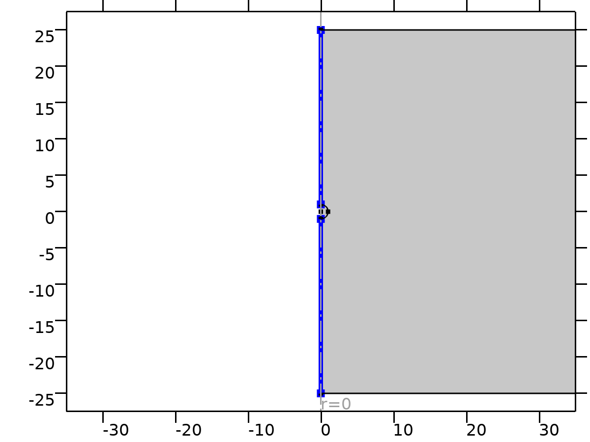

Axial Symmetry 1

Selection

|  |  |
| --- | --- |
| Geometric entity level | Boundary |
| Selection | Geometry geom1: Dimension 1: All boundaries |

#### Constraints

| **Constraint** | **Constraint force** | **Shape function** | **Selection** | **Details** |
| --- | --- | --- | --- | --- |
| -u | test(-u) | Lagrange (Linear) | Boundaries 1, 5 | Elemental |

* + 1. Wall 1

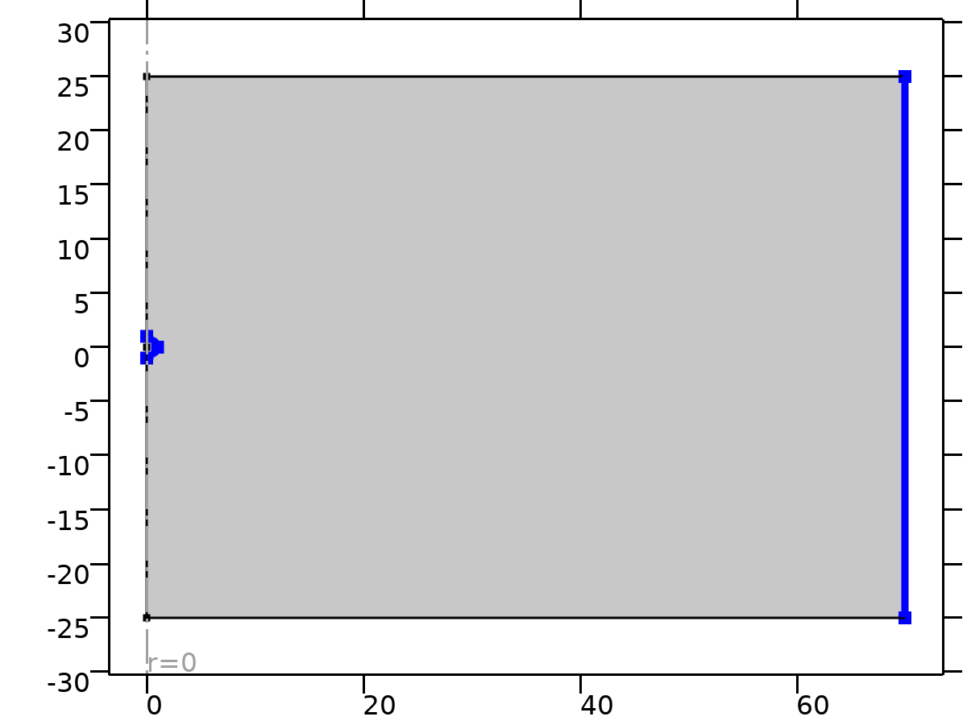

Wall 1

Selection

|  |  |
| --- | --- |
| Geometric entity level | Boundary |
| Selection | Geometry geom1: Dimension 1: All boundaries |

Equations



#### Boundary Condition

Settings

| **Description** | **Value** |
| --- | --- |
| Wall condition | No slip |

#### Wall Movement

Settings

| **Description** | **Value** |
| --- | --- |
| Translational velocity | Automatic from frame |
| Sliding wall | Off |

#### Variables

| **Name** | **Expression** | **Description** | **Selection** | **Details** |
| --- | --- | --- | --- | --- |
| spf.ubndr | spf.utrr+spf.usr | Velocity at boundary, r component | Boundaries 7–9 |  |
| spf.ubndphi | spf.utrphi+spf.usphi | Velocity at boundary, phi component | Boundaries 7–9 |  |
| spf.ubndz | spf.utrz+spf.usz | Velocity at boundary, z component | Boundaries 7–9 |  |
| spf.usr | 0 | Velocity of sliding wall, r component | Boundaries 7–9 |  |
| spf.usphi | 0 | Velocity of sliding wall, phi component | Boundaries 7–9 |  |
| spf.usz | 0 | Velocity of sliding wall, z component | Boundaries 7–9 |  |
| spf.utrr | 0 | Velocity of moving wall, r component | Boundaries 7–9 |  |
| spf.utrphi | 0 | Velocity of moving wall, phi component | Boundaries 7–9 |  |
| spf.utrz | 0 | Velocity of moving wall, z component | Boundaries 7–9 |  |
| spf.uLeakager | 0 | Leakage velocity, r component | Boundaries 7–9 | + operation |
| spf.uLeakagephi | 0 | Leakage velocity, phi component | Boundaries 7–9 | + operation |
| spf.uLeakagez | 0 | Leakage velocity, z component | Boundaries 7–9 | + operation |
| spf.noSlipWall | 1 | Help variable | Boundaries 7–9 |  |

#### Constraints

| **Constraint** | **Constraint force** | **Shape function** | **Selection** | **Details** |
| --- | --- | --- | --- | --- |
| -u+spf.ubndr+spf.uLeakager | test(-u) | Lagrange (Linear) | Boundaries 7–9 | Elemental |
| spf.ubndphi+spf.uLeakagephi | 0 |  | Boundaries 7–9 | Elemental |
| -w+spf.ubndz+spf.uLeakagez | test(-w) | Lagrange (Linear) | Boundaries 7–9 | Elemental |

* + 1. Inlet 1

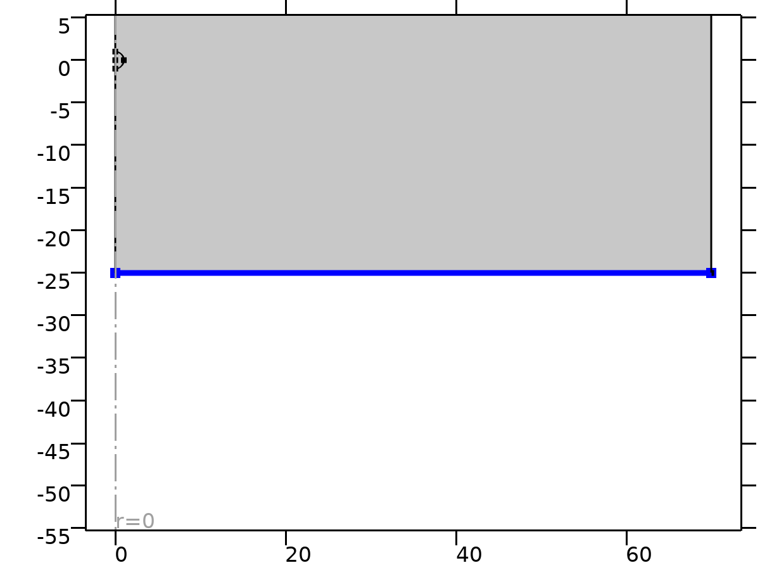

Inlet 1

Selection

|  |  |
| --- | --- |
| Geometric entity level | Boundary |
| Selection | Geometry geom1: Dimension 1: Boundary 2 |

Equations



#### Boundary Condition

Settings

| **Description** | **Value** |
| --- | --- |
| Boundary condition | Velocity |

#### Velocity

Settings

| **Description** | **Value** |
| --- | --- |
| Velocity field componentwise | Velocity field |
| Velocity field, r component | 0 |
| Velocity field, phi component | 0 |
| Velocity field, z component | 1 |

#### Variables

| **Name** | **Expression** | **Description** | **Selection** | **Details** |
| --- | --- | --- | --- | --- |
| spf.u0r | 0 | Velocity field, r component | Boundary 2 |  |
| spf.u0phi | 0 | Velocity field, phi component | Boundary 2 |  |
| spf.u0z | 1 | Velocity field, z component | Boundary 2 |  |
| spf.inl1.dz | spf.dz | Channel thickness | Boundary 2 |  |
| spf.inl1.volumeFlowRate | spf.inl1.intop(2*(u*spf.nrmesh+w*spf.nzmesh)*pi*r) | Outward volume flow rate across feature selection | Global |  |
| spf.inl1.massFlowRate | spf.inl1.intop(2*spf.rho*(u*spf.nrmesh+w*spf.nzmesh)*pi*r) | Outward mass flow rate across feature selection | Global |  |
| spf.inl1.pAverage | spf.inl1.intop(2*p*pi*r)/max(spf.inl1.intop(2*pi*r),1000*eps) | Pressure average over feature selection | Global |  |

#### Constraints

| **Constraint** | **Constraint force** | **Shape function** | **Selection** | **Details** |
| --- | --- | --- | --- | --- |
| -u+spf.u0r | test(-u) | Lagrange (Linear) | Boundary 2 | Elemental |
| spf.u0phi | 0 |  | Boundary 2 | Elemental |
| -w+spf.u0z | test(-w) | Lagrange (Linear) | Boundary 2 | Elemental |

* + 1. Outlet 1

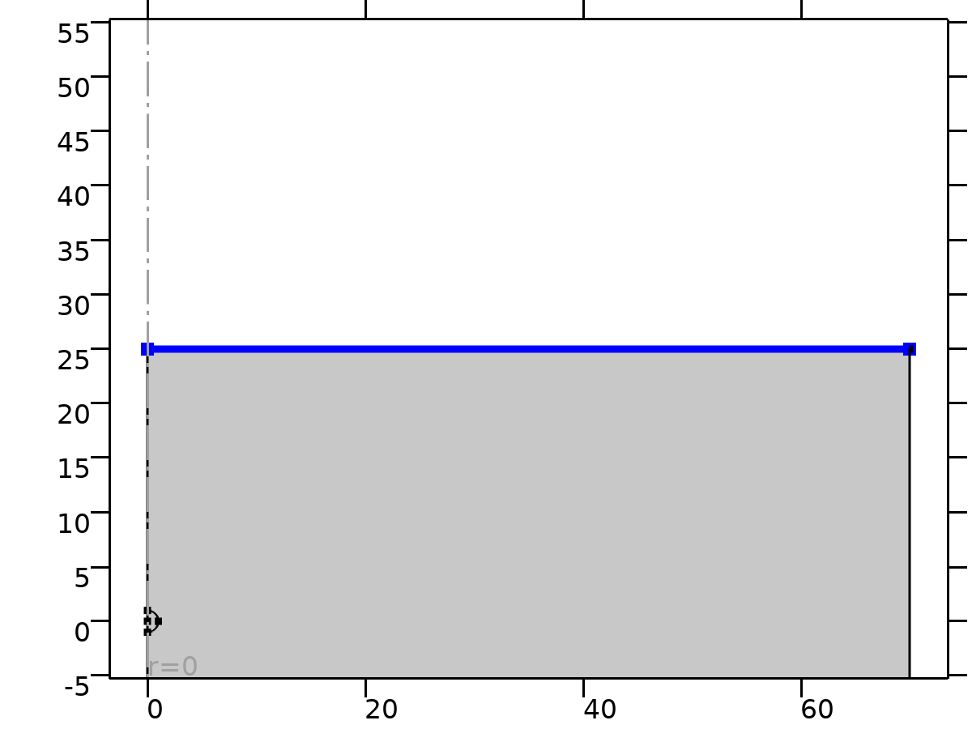

Outlet 1

Selection

|  |  |
| --- | --- |
| Geometric entity level | Boundary |
| Selection | Geometry geom1: Dimension 1: Boundary 6 |

Equations





#### Boundary Condition

Settings

| **Description** | **Value** |
| --- | --- |
| Boundary condition | Pressure |

#### Pressure Conditions

Settings

| **Description** | **Value** |
| --- | --- |
| Pressure | Static |
| Pressure | 0 |
| Normal flow | Off |
| Suppress backflow | On |

#### Variables

| **Name** | **Expression** | **Description** | **Selection** | **Details** |
| --- | --- | --- | --- | --- |
| spf.meshVol | meshvol_spatial |  | Boundary 6 |  |
| spf.meshVolInt | down(meshvol_spatial) | Volume of interior mesh element | Boundary 6 |  |
| spf.c_here | 96/spf.epsilon_p | Intermediate variable | Boundary 6 |  |
| spf.rhoFace | down(spf.rho) | Density face value | Boundary 6 |  |
| spf.umxTnFace | spf.upwind_helpr*spf.nrmesh+spf.upwind_helpphi*spf.nphimesh+spf.upwind_helpz*spf.nzmesh | Relative velocity on face | Boundary 6 |  |
| spf.upwind_ns | spf.backflowPenaltyConv*spf.uNormal | Upwind term | Boundary 6 |  |
| spf.p0 | 0 | Pressure | Boundary 6 |  |
| spf.out1.Uav | 0 | Average velocity | Global |  |
| spf.out1.p0avfdf | 0 | Average pressure | Global |  |
| spf.out1.dz | spf.dz | Channel thickness | Boundary 6 |  |
| spf.out1.Mflow | spf.out1.massFlowRate | Mass flow | Global |  |
| spf.f0 | spf.p0+spf.uNormal*(spf.backflowPenaltyDiff-spf.backflowPenaltyConv)*(spf.uNormal<0) | Normal stress | Boundary 6 |  |
| spf.uNormal | u*nojac(spf.nrmesh)+w*nojac(spf.nzmesh) | Normal velocity | Boundary 6 |  |
| spf.backflowPenaltyDiff | spf.c_here*min((down(spf.mu)+spf.muT)*spf.meshVol/spf.meshVolInt,down(spf.rho)*abs(spf.uNormal)/down(spf.epsilon_p)) | Backflow penalty parameter, diffusive contribution | Boundary 6 |  |
| spf.backflowPenaltyConv | spf.rhoFace*spf.umxTnFace/spf.epsilon_p^2 | Backflow penalty parameter, convective contribution | Boundary 6 |  |
| spf.out1.volumeFlowRate | spf.out1.intop(2*(u*spf.nrmesh+w*spf.nzmesh)*pi*r) | Outward volume flow rate across feature selection | Global |  |
| spf.out1.massFlowRate | spf.out1.intop(2*spf.rho*(u*spf.nrmesh+w*spf.nzmesh)*pi*r) | Outward mass flow rate across feature selection | Global |  |
| spf.out1.pAverage | spf.out1.intop(2*p*pi*r)/max(spf.out1.intop(2*pi*r),1000*eps) | Pressure average over feature selection | Global |  |

#### Weak Expressions

| **Weak expression** | **Integration order** | **Integration frame** | **Selection** |
| --- | --- | --- | --- |
| -2*spf.f0*(test(u)*spf.nrmesh+test(w)*spf.nzmesh)*pi*r | 2 | Spatial | Boundary 6 |

* 1. Mesh 1

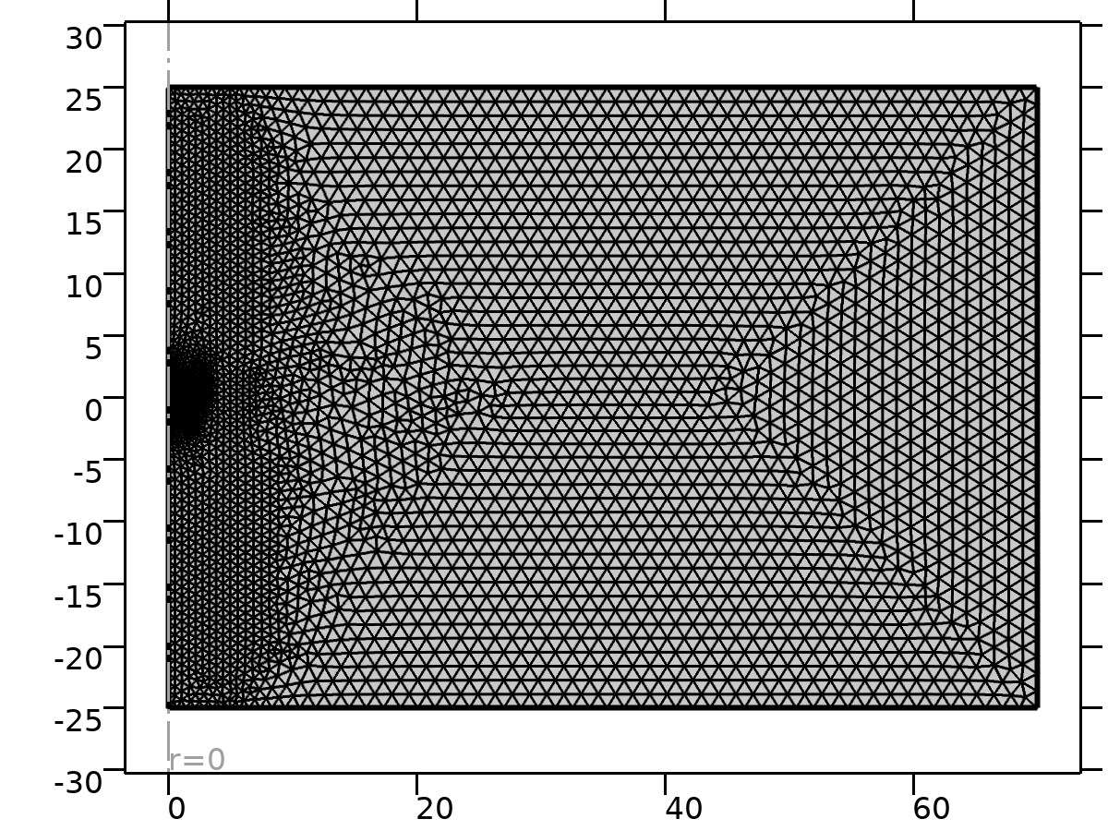

Mesh 1

Mesh statistics

| **Description** | **Value** |
| --- | --- |
| Minimum element quality | 0.7268 |
| Average element quality | 0.9803 |
| Triangle | 7102 |
| Edge element | 252 |
| Vertex element | 8 |

* + 1. Size (size)

Settings

| **Description** | **Value** |
| --- | --- |
| Calibrate for | Fluid dynamics |
| Maximum element size | 1.4 |
| Minimum element size | 0.02 |
| Curvature factor | 0.25 |
| Predefined size | Finer |

* + 1. Free Triangular 2 (ftri2)

Selection

|  |  |
| --- | --- |
| Geometric entity level | Domain |
| Selection | Remaining |

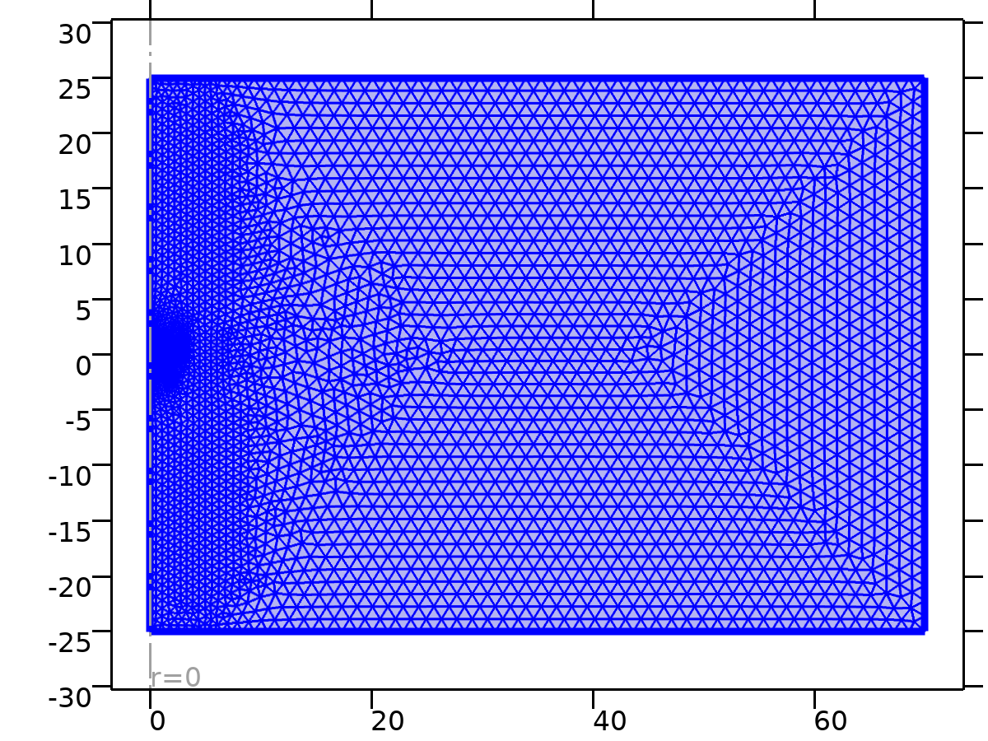

Free Triangular 2

Settings

| **Description** | **Value** |
| --- | --- |
| Number of iterations | 4 |
| Maximum element depth to process | 4 |

#### Size 1 (size1)

Selection

|  |  |
| --- | --- |
| Geometric entity level | Domain |
| Selection | Geometry geom1: Dimension 2: Domain 1 |

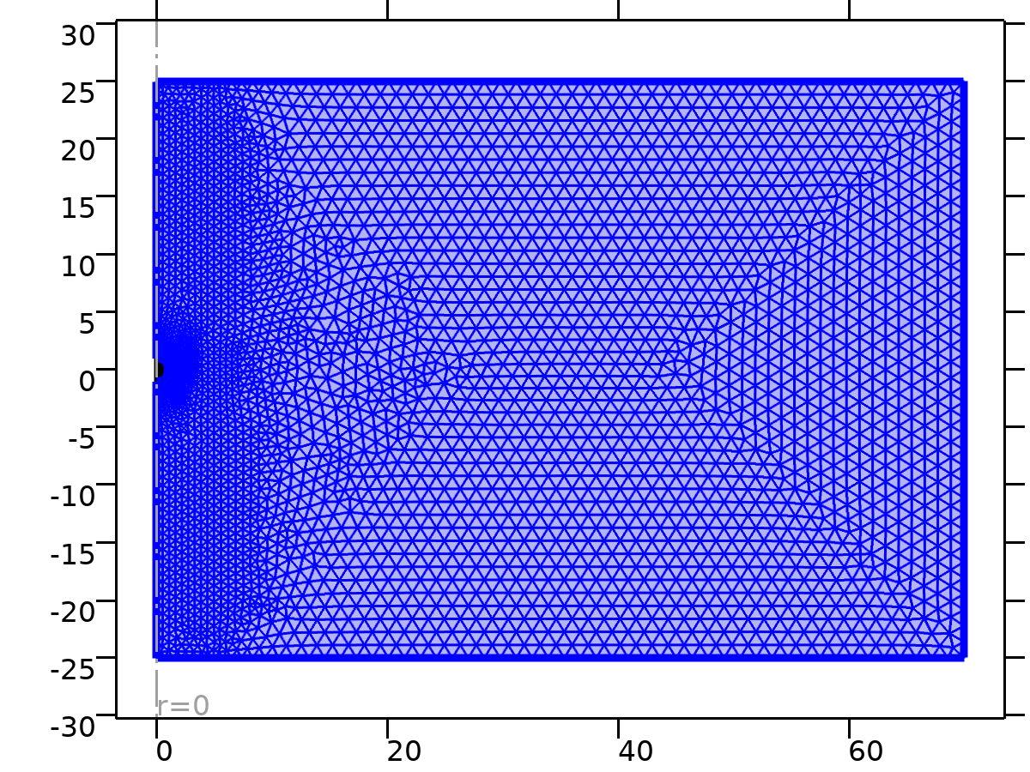

Size 1

Settings

| **Description** | **Value** |
| --- | --- |
| Maximum element size | 0.7 |
| Minimum element size | 0.0014 |
| Curvature factor | 0.2 |
| Predefined size | Extremely fine |

1. Study 1

Computation information

|  |  |
| --- | --- |
| Computation time | 18 s |

* 1. Stationary

Study settings

| **Description** | **Value** |
| --- | --- |
| Include geometric nonlinearity | Off |

Study extensions

| **Description** | **Value** |
| --- | --- |
| Auxiliary sweep | On |
| Sweep type | All combinations |

Parameters

| **Parameter name** | **Parameter value list** | **Parameter unit** |
| --- | --- | --- |
| Re | range(0.1,0.01,1) |  |

Physics and variables selection

| **Physics interface** | **Discretization** |
| --- | --- |
| Laminar Flow (spf) | physics |

Mesh selection

| **Geometry** | **Mesh** |
| --- | --- |
| Geometry 1 (geom1) | mesh1 |

* + 1. Study extensions

Study extensions

| **Description** | **Value** |
| --- | --- |
| Auxiliary sweep | On |
| Sweep type | All combinations |

Parameters

| **Parameter name** | **Parameter value list** | **Parameter unit** |
| --- | --- | --- |
| Re | range(0.1,0.01,1) |  |

* 1. Solver Configurations
     1. Solution 1

#### Compile Equations: Stationary (st1)

Study and step

| **Description** | **Value** |
| --- | --- |
| Use study | Study 1 |
| Use study step | Stationary |

Log

<---- Compile Equations: Stationary in Study 1/Solution 1 (sol1) ---------------

Started at Nov 24, 2024 3:38:31 AM.

Geometry shape function: Linear Lagrange

Running on AMD64 Family 23 Model 104 Stepping 1, AuthenticAMD.

Using 1 socket with 6 cores in total on DESKTOP-JN273BM.

Available memory: 7.52 GB.

Time: 1 s.

Physical memory: 1.42 GB

Virtual memory: 1.85 GB

Ended at Nov 24, 2024 3:38:32 AM.

----- Compile Equations: Stationary in Study 1/Solution 1 (sol1) -------------->

#### Dependent Variables 1 (v1)

General

| **Description** | **Value** |
| --- | --- |
| Defined by study step | Stationary |

Initial value calculation constants

| **Constant name** | **Initial value source** |
| --- | --- |
| Re | range(0.1,0.01,1) |

Log

<---- Dependent Variables 1 in Study 1/Solution 1 (sol1) -----------------------

Started at Nov 24, 2024 3:38:32 AM.

Solution time: 0 s.

Physical memory: 1.42 GB

Virtual memory: 1.85 GB

Ended at Nov 24, 2024 3:38:32 AM.

----- Dependent Variables 1 in Study 1/Solution 1 (sol1) ---------------------->

##### Pressure (comp1.p) (comp1_p)

General

| **Description** | **Value** |
| --- | --- |
| Field components | comp1.p |

##### Velocity field (comp1.u) (comp1_u)

General

| **Description** | **Value** |
| --- | --- |
| Field components | {comp1.u, comp1.w} |
| Internal variables | comp1.spf.isFluidHasBeenSolved |

#### Stationary Solver 1 (s1)

General

| **Description** | **Value** |
| --- | --- |
| Defined by study step | Stationary |

Results while solving

| **Description** | **Value** |
| --- | --- |
| Probes | None |

Log

<---- Stationary Solver 1 in Study 1/Solution 1 (sol1) -------------------------

Started at Nov 24, 2024 3:38:32 AM.

Continuation solver

Nonlinear solver

Number of degrees of freedom solved for: 10872 (plus 1 internal DOFs).

Continuation parameter Re = 0.1.

Nonsymmetric matrix found.

Scales for dependent variables:

Pressure (comp1.p): 1

Velocity field (comp1.u): 0.1

Orthonormal null-space function used.

Iter      SolEst      ResEst     Damping    Stepsize #Res #Jac #Sol   LinErr   LinRes

   1           6     9.7e+02   0.0100000           6    2    1    2  9.2e-15  2.8e-15

   2         4.1     5.6e+05   0.1000000         4.5    3    2    4  2.3e-15  2.8e-15

   3        0.27     4.4e+07   1.0000000        0.65    4    3    6  4.6e-15  6.6e-14

   4       0.003     6.2e+05   1.0000000        0.22    5    4    8  3.5e-15  3.6e-14

   5     2.3e-06       0.029   1.0000000      0.0069    7    5   10  2.6e-15  1.3e-14

Continuation parameter Re = 0.11.

Iter      SolEst      ResEst     Damping    Stepsize #Res #Jac #Sol   LinErr   LinRes

   1     3.4e-07      0.0001   1.0000000      0.0017   12    6   13  3.4e-15  2.1e-14

Continuation parameter Re = 0.12.

Iter      SolEst      ResEst     Damping    Stepsize #Res #Jac #Sol   LinErr   LinRes

   1     3.2e-07     0.00011   1.0000000      0.0015   17    7   16  2.6e-15  1.7e-14

Continuation parameter Re = 0.13.

Iter      SolEst      ResEst     Damping    Stepsize #Res #Jac #Sol   LinErr   LinRes

   1     3.1e-07     0.00011   1.0000000      0.0013   22    8   19    3e-15  1.7e-14

Continuation parameter Re = 0.14.

Iter      SolEst      ResEst     Damping    Stepsize #Res #Jac #Sol   LinErr   LinRes

   1       3e-07     0.00012   1.0000000      0.0012   27    9   22    2e-15  1.6e-14

Continuation parameter Re = 0.15.

Iter      SolEst      ResEst     Damping    Stepsize #Res #Jac #Sol   LinErr   LinRes

   1     2.9e-07     0.00013   1.0000000       0.001   32   10   25  2.6e-15  1.6e-14

Continuation parameter Re = 0.16.

Iter      SolEst      ResEst     Damping    Stepsize #Res #Jac #Sol   LinErr   LinRes

   1     2.9e-07     0.00014   1.0000000     0.00092   37   11   28  1.8e-15  1.7e-14

Continuation parameter Re = 0.17.

Iter      SolEst      ResEst     Damping    Stepsize #Res #Jac #Sol   LinErr   LinRes

   1     2.8e-07     0.00016   1.0000000     0.00082   42   12   31  2.2e-15  1.6e-14

Continuation parameter Re = 0.18.

Iter      SolEst      ResEst     Damping    Stepsize #Res #Jac #Sol   LinErr   LinRes

   1     2.8e-07     0.00018   1.0000000     0.00073   47   13   34  1.8e-15  1.5e-14

Continuation parameter Re = 0.19.

Iter      SolEst      ResEst     Damping    Stepsize #Res #Jac #Sol   LinErr   LinRes

   1     2.7e-07      0.0002   1.0000000     0.00066   52   14   37  2.9e-15  1.5e-14

Continuation parameter Re = 0.2.

Iter      SolEst      ResEst     Damping    Stepsize #Res #Jac #Sol   LinErr   LinRes

   1     2.7e-07     0.00023   1.0000000     0.00059   57   15   40  3.1e-15  1.4e-14

Continuation parameter Re = 0.21.

Iter      SolEst      ResEst     Damping    Stepsize #Res #Jac #Sol   LinErr   LinRes

   1     2.6e-07     0.00027   1.0000000     0.00053   62   16   43  2.2e-15  1.5e-14

Continuation parameter Re = 0.22.

Iter      SolEst      ResEst     Damping    Stepsize #Res #Jac #Sol   LinErr   LinRes

   1     2.6e-07     0.00032   1.0000000     0.00048   67   17   46  1.9e-15  1.4e-14

Continuation parameter Re = 0.23.

Iter      SolEst      ResEst     Damping    Stepsize #Res #Jac #Sol   LinErr   LinRes

   1     2.6e-07     0.00037   1.0000000     0.00044   72   18   49  1.7e-15  1.4e-14

Continuation parameter Re = 0.24.

Iter      SolEst      ResEst     Damping    Stepsize #Res #Jac #Sol   LinErr   LinRes

   1     2.5e-07     0.00043   1.0000000      0.0004   77   19   52  3.1e-15  1.2e-14

Continuation parameter Re = 0.25.

Iter      SolEst      ResEst     Damping    Stepsize #Res #Jac #Sol   LinErr   LinRes

   1     2.5e-07      0.0005   1.0000000     0.00037   82   20   55  2.2e-15  1.2e-14

Continuation parameter Re = 0.26.

Iter      SolEst      ResEst     Damping    Stepsize #Res #Jac #Sol   LinErr   LinRes

   1     2.5e-07     0.00058   1.0000000     0.00034   87   21   58  1.9e-15  1.2e-14

Continuation parameter Re = 0.27.

Iter      SolEst      ResEst     Damping    Stepsize #Res #Jac #Sol   LinErr   LinRes

   1     2.5e-07     0.00066   1.0000000     0.00031   92   22   61  1.7e-15  1.1e-14

Continuation parameter Re = 0.28.

Iter      SolEst      ResEst     Damping    Stepsize #Res #Jac #Sol   LinErr   LinRes

   1     2.4e-07     0.00076   1.0000000     0.00029   97   23   64  2.1e-15  1.1e-14

Continuation parameter Re = 0.29.

Iter      SolEst      ResEst     Damping    Stepsize #Res #Jac #Sol   LinErr   LinRes

   1     2.4e-07     0.00088   1.0000000     0.00027  102   24   67  1.7e-15    1e-14

Continuation parameter Re = 0.3.

Iter      SolEst      ResEst     Damping    Stepsize #Res #Jac #Sol   LinErr   LinRes

   1     2.4e-07       0.001   1.0000000     0.00025  107   25   70  1.2e-15  9.5e-15

Continuation parameter Re = 0.31.

Iter      SolEst      ResEst     Damping    Stepsize #Res #Jac #Sol   LinErr   LinRes

   1     2.3e-07      0.0011   1.0000000     0.00023  112   26   73  2.7e-15    9e-15

Continuation parameter Re = 0.32.

Iter      SolEst      ResEst     Damping    Stepsize #Res #Jac #Sol   LinErr   LinRes

   1     2.3e-07      0.0013   1.0000000     0.00021  117   27   76  2.3e-15  8.8e-15

Continuation parameter Re = 0.33.

Iter      SolEst      ResEst     Damping    Stepsize #Res #Jac #Sol   LinErr   LinRes

   1     2.3e-07      0.0015   1.0000000      0.0002  122   28   79  1.7e-15  8.1e-15

Continuation parameter Re = 0.34.

Iter      SolEst      ResEst     Damping    Stepsize #Res #Jac #Sol   LinErr   LinRes

   1     2.3e-07      0.0016   1.0000000     0.00019  127   29   82    2e-15  8.1e-15

Continuation parameter Re = 0.35.

Iter      SolEst      ResEst     Damping    Stepsize #Res #Jac #Sol   LinErr   LinRes

   1     2.2e-07      0.0018   1.0000000     0.00018  132   30   85  1.2e-15  7.8e-15

Continuation parameter Re = 0.36.

Iter      SolEst      ResEst     Damping    Stepsize #Res #Jac #Sol   LinErr   LinRes

   1     2.2e-07      0.0021   1.0000000     0.00017  137   31   88  1.8e-15  7.3e-15

Continuation parameter Re = 0.37.

Iter      SolEst      ResEst     Damping    Stepsize #Res #Jac #Sol   LinErr   LinRes

   1     2.2e-07      0.0023   1.0000000     0.00016  142   32   91  1.8e-15  6.7e-15

Continuation parameter Re = 0.38.

Iter      SolEst      ResEst     Damping    Stepsize #Res #Jac #Sol   LinErr   LinRes

   1     2.2e-07      0.0026   1.0000000     0.00015  147   33   94  1.3e-15  6.6e-15

Continuation parameter Re = 0.39.

Iter      SolEst      ResEst     Damping    Stepsize #Res #Jac #Sol   LinErr   LinRes

   1     2.2e-07      0.0029   1.0000000     0.00014  152   34   97  1.5e-15  6.6e-15

Continuation parameter Re = 0.4.

Iter      SolEst      ResEst     Damping    Stepsize #Res #Jac #Sol   LinErr   LinRes

   1     2.1e-07      0.0032   1.0000000     0.00013  157   35  100  2.3e-15  6.3e-15

Continuation parameter Re = 0.41.

Iter      SolEst      ResEst     Damping    Stepsize #Res #Jac #Sol   LinErr   LinRes

   1     2.1e-07      0.0035   1.0000000     0.00013  162   36  103  1.1e-15  6.5e-15

Continuation parameter Re = 0.42.

Iter      SolEst      ResEst     Damping    Stepsize #Res #Jac #Sol   LinErr   LinRes

   1     2.1e-07      0.0039   1.0000000     0.00012  167   37  106  1.6e-15  6.2e-15

Continuation parameter Re = 0.43.

Iter      SolEst      ResEst     Damping    Stepsize #Res #Jac #Sol   LinErr   LinRes

   1     2.1e-07      0.0043   1.0000000     0.00011  172   38  109  1.2e-15  6.2e-15

Continuation parameter Re = 0.44.

Iter      SolEst      ResEst     Damping    Stepsize #Res #Jac #Sol   LinErr   LinRes

   1     2.1e-07      0.0046   1.0000000     0.00011  177   39  112    2e-15    6e-15

Continuation parameter Re = 0.45.

Iter      SolEst      ResEst     Damping    Stepsize #Res #Jac #Sol   LinErr   LinRes

   1     2.1e-07      0.0052   1.0000000      0.0001  182   40  115  1.5e-15  5.8e-15

Continuation parameter Re = 0.46.

Iter      SolEst      ResEst     Damping    Stepsize #Res #Jac #Sol   LinErr   LinRes

   1     2.1e-07      0.0058   1.0000000     9.9e-05  187   41  118  1.3e-15  5.1e-15

Continuation parameter Re = 0.47.

Iter      SolEst      ResEst     Damping    Stepsize #Res #Jac #Sol   LinErr   LinRes

   1       2e-07      0.0062   1.0000000     9.5e-05  192   42  121    2e-15  5.1e-15

Continuation parameter Re = 0.48.

Iter      SolEst      ResEst     Damping    Stepsize #Res #Jac #Sol   LinErr   LinRes

   1       2e-07      0.0067   1.0000000     9.1e-05  197   43  124  1.5e-15  4.8e-15

Continuation parameter Re = 0.49.

Iter      SolEst      ResEst     Damping    Stepsize #Res #Jac #Sol   LinErr   LinRes

   1       2e-07      0.0074   1.0000000     8.7e-05  202   44  127  1.7e-15  5.1e-15

Continuation parameter Re = 0.5.

Iter      SolEst      ResEst     Damping    Stepsize #Res #Jac #Sol   LinErr   LinRes

   1       2e-07       0.008   1.0000000     8.4e-05  207   45  130  1.9e-15  4.7e-15

Continuation parameter Re = 0.51.

Iter      SolEst      ResEst     Damping    Stepsize #Res #Jac #Sol   LinErr   LinRes

   1       2e-07      0.0087   1.0000000     8.1e-05  212   46  133  1.6e-15  4.8e-15

Continuation parameter Re = 0.52.

Iter      SolEst      ResEst     Damping    Stepsize #Res #Jac #Sol   LinErr   LinRes

   1       2e-07      0.0093   1.0000000     7.8e-05  217   47  136  1.8e-15    5e-15

Continuation parameter Re = 0.53.

Iter      SolEst      ResEst     Damping    Stepsize #Res #Jac #Sol   LinErr   LinRes

   1       2e-07        0.01   1.0000000     7.5e-05  222   48  139  1.4e-15  4.7e-15

Continuation parameter Re = 0.54.

Iter      SolEst      ResEst     Damping    Stepsize #Res #Jac #Sol   LinErr   LinRes

   1       2e-07       0.011   1.0000000     7.2e-05  227   49  142  1.5e-15  4.7e-15

Continuation parameter Re = 0.55.

Iter      SolEst      ResEst     Damping    Stepsize #Res #Jac #Sol   LinErr   LinRes

   1       2e-07       0.012   1.0000000       7e-05  232   50  145  1.6e-15  4.7e-15

Continuation parameter Re = 0.56.

Iter      SolEst      ResEst     Damping    Stepsize #Res #Jac #Sol   LinErr   LinRes

   1       2e-07       0.013   1.0000000     6.8e-05  237   51  148  1.3e-15  4.1e-15

Continuation parameter Re = 0.57.

Iter      SolEst      ResEst     Damping    Stepsize #Res #Jac #Sol   LinErr   LinRes

   1       2e-07       0.014   1.0000000     6.5e-05  242   52  151  1.2e-15  3.9e-15

Continuation parameter Re = 0.58.

Iter      SolEst      ResEst     Damping    Stepsize #Res #Jac #Sol   LinErr   LinRes

   1       2e-07       0.014   1.0000000     6.3e-05  247   53  154  1.5e-15  4.1e-15

Continuation parameter Re = 0.59.

Iter      SolEst      ResEst     Damping    Stepsize #Res #Jac #Sol   LinErr   LinRes

   1     1.9e-07       0.015   1.0000000     6.2e-05  252   54  157  2.2e-15    4e-15

Continuation parameter Re = 0.6.

Iter      SolEst      ResEst     Damping    Stepsize #Res #Jac #Sol   LinErr   LinRes

   1     1.9e-07       0.017   1.0000000       6e-05  257   55  160  9.8e-16  3.9e-15

Continuation parameter Re = 0.61.

Iter      SolEst      ResEst     Damping    Stepsize #Res #Jac #Sol   LinErr   LinRes

   1     1.9e-07       0.018   1.0000000     5.8e-05  262   56  163  1.3e-15  3.9e-15

Continuation parameter Re = 0.62.

Iter      SolEst      ResEst     Damping    Stepsize #Res #Jac #Sol   LinErr   LinRes

   1     1.9e-07       0.019   1.0000000     5.7e-05  267   57  166  1.4e-15  3.9e-15

Continuation parameter Re = 0.63.

Iter      SolEst      ResEst     Damping    Stepsize #Res #Jac #Sol   LinErr   LinRes

   1     1.9e-07        0.02   1.0000000     5.5e-05  272   58  169  1.2e-15    4e-15

Continuation parameter Re = 0.64.

Iter      SolEst      ResEst     Damping    Stepsize #Res #Jac #Sol   LinErr   LinRes

   1     1.9e-07       0.022   1.0000000     5.4e-05  277   59  172  1.7e-15  3.7e-15

Continuation parameter Re = 0.65.

Iter      SolEst      ResEst     Damping    Stepsize #Res #Jac #Sol   LinErr   LinRes

   1     1.9e-07       0.023   1.0000000     5.2e-05  282   60  175  1.3e-15  3.6e-15

Continuation parameter Re = 0.66.

Iter      SolEst      ResEst     Damping    Stepsize #Res #Jac #Sol   LinErr   LinRes

   1     1.9e-07       0.024   1.0000000     5.1e-05  287   61  178    1e-15  3.6e-15

Continuation parameter Re = 0.67.

Iter      SolEst      ResEst     Damping    Stepsize #Res #Jac #Sol   LinErr   LinRes

   1     1.9e-07       0.026   1.0000000       5e-05  292   62  181  1.3e-15  3.6e-15

Continuation parameter Re = 0.68.

Iter      SolEst      ResEst     Damping    Stepsize #Res #Jac #Sol   LinErr   LinRes

   1     1.9e-07       0.027   1.0000000     4.9e-05  297   63  184  1.4e-15  3.4e-15

Continuation parameter Re = 0.69.

Iter      SolEst      ResEst     Damping    Stepsize #Res #Jac #Sol   LinErr   LinRes

   1     1.9e-07       0.029   1.0000000     4.8e-05  302   64  187  1.2e-15  3.4e-15

Continuation parameter Re = 0.7.

Iter      SolEst      ResEst     Damping    Stepsize #Res #Jac #Sol   LinErr   LinRes

   1     1.9e-07       0.031   1.0000000     4.7e-05  307   65  190  1.5e-15  3.3e-15

Continuation parameter Re = 0.71.

Iter      SolEst      ResEst     Damping    Stepsize #Res #Jac #Sol   LinErr   LinRes

   1     1.9e-07       0.032   1.0000000     4.6e-05  312   66  193  1.7e-15  3.3e-15

Continuation parameter Re = 0.72.

Iter      SolEst      ResEst     Damping    Stepsize #Res #Jac #Sol   LinErr   LinRes

   1     1.9e-07       0.034   1.0000000     4.5e-05  317   67  196    1e-15  3.3e-15

Continuation parameter Re = 0.73.

Iter      SolEst      ResEst     Damping    Stepsize #Res #Jac #Sol   LinErr   LinRes

   1     1.9e-07       0.036   1.0000000     4.5e-05  322   68  199  1.3e-15  3.2e-15

Continuation parameter Re = 0.74.

Iter      SolEst      ResEst     Damping    Stepsize #Res #Jac #Sol   LinErr   LinRes

   1     1.8e-07       0.038   1.0000000     4.4e-05  327   69  202  1.4e-15  3.3e-15

Continuation parameter Re = 0.75.

Iter      SolEst      ResEst     Damping    Stepsize #Res #Jac #Sol   LinErr   LinRes

   1     1.8e-07       0.039   1.0000000     4.3e-05  332   70  205  1.2e-15  3.2e-15

Continuation parameter Re = 0.76.

Iter      SolEst      ResEst     Damping    Stepsize #Res #Jac #Sol   LinErr   LinRes

   1     1.8e-07       0.041   1.0000000     4.3e-05  337   71  208  1.4e-15  3.1e-15

Continuation parameter Re = 0.77.

Iter      SolEst      ResEst     Damping    Stepsize #Res #Jac #Sol   LinErr   LinRes

   1     1.8e-07       0.044   1.0000000     4.2e-05  342   72  211  1.5e-15    3e-15

Continuation parameter Re = 0.78.

Iter      SolEst      ResEst     Damping    Stepsize #Res #Jac #Sol   LinErr   LinRes

   1     1.8e-07       0.046   1.0000000     4.1e-05  347   73  214  1.3e-15    3e-15

Continuation parameter Re = 0.79.

Iter      SolEst      ResEst     Damping    Stepsize #Res #Jac #Sol   LinErr   LinRes

   1     1.8e-07       0.051   1.0000000     4.1e-05  352   74  217  1.3e-15  2.8e-15

Continuation parameter Re = 0.8.

Iter      SolEst      ResEst     Damping    Stepsize #Res #Jac #Sol   LinErr   LinRes

   1     1.8e-07       0.054   1.0000000       4e-05  357   75  220  1.3e-15  2.7e-15

Continuation parameter Re = 0.81.

Iter      SolEst      ResEst     Damping    Stepsize #Res #Jac #Sol   LinErr   LinRes

   1     1.8e-07       0.056   1.0000000       4e-05  362   76  223  1.2e-15  2.5e-15

Continuation parameter Re = 0.82.

Iter      SolEst      ResEst     Damping    Stepsize #Res #Jac #Sol   LinErr   LinRes

   1     1.8e-07       0.058   1.0000000       4e-05  367   77  226  1.1e-15  2.7e-15

Continuation parameter Re = 0.83.

Iter      SolEst      ResEst     Damping    Stepsize #Res #Jac #Sol   LinErr   LinRes

   1     1.8e-07        0.06   1.0000000     3.9e-05  372   78  229    1e-15  2.6e-15

Continuation parameter Re = 0.84.

Iter      SolEst      ResEst     Damping    Stepsize #Res #Jac #Sol   LinErr   LinRes

   1     1.8e-07       0.062   1.0000000     3.9e-05  377   79  232  1.2e-15  2.6e-15

Continuation parameter Re = 0.85.

Iter      SolEst      ResEst     Damping    Stepsize #Res #Jac #Sol   LinErr   LinRes

   1     1.8e-07       0.067   1.0000000     3.8e-05  382   80  235  1.3e-15  2.5e-15

Continuation parameter Re = 0.86.

Iter      SolEst      ResEst     Damping    Stepsize #Res #Jac #Sol   LinErr   LinRes

   1     1.8e-07       0.069   1.0000000     3.8e-05  387   81  238  9.1e-16  2.5e-15

Continuation parameter Re = 0.87.

Iter      SolEst      ResEst     Damping    Stepsize #Res #Jac #Sol   LinErr   LinRes

   1     1.8e-07       0.071   1.0000000     3.8e-05  392   82  241    1e-15  2.5e-15

Continuation parameter Re = 0.88.

Iter      SolEst      ResEst     Damping    Stepsize #Res #Jac #Sol   LinErr   LinRes

   1     1.8e-07       0.077   1.0000000     3.7e-05  397   83  244    1e-15  2.5e-15

Continuation parameter Re = 0.89.

Iter      SolEst      ResEst     Damping    Stepsize #Res #Jac #Sol   LinErr   LinRes

   1     1.8e-07        0.08   1.0000000     3.7e-05  402   84  247  9.1e-16  2.4e-15

Continuation parameter Re = 0.9.

Iter      SolEst      ResEst     Damping    Stepsize #Res #Jac #Sol   LinErr   LinRes

   1     1.8e-07       0.084   1.0000000     3.7e-05  407   85  250  7.5e-16  2.3e-15

Continuation parameter Re = 0.91.

Iter      SolEst      ResEst     Damping    Stepsize #Res #Jac #Sol   LinErr   LinRes

   1     1.8e-07       0.086   1.0000000     3.7e-05  412   86  253  9.6e-16  2.3e-15

Continuation parameter Re = 0.92.

Iter      SolEst      ResEst     Damping    Stepsize #Res #Jac #Sol   LinErr   LinRes

   1     1.8e-07       0.089   1.0000000     3.6e-05  417   87  256  1.1e-15  2.3e-15

Continuation parameter Re = 0.93.

Iter      SolEst      ResEst     Damping    Stepsize #Res #Jac #Sol   LinErr   LinRes

   1     1.8e-07       0.092   1.0000000     3.6e-05  422   88  259  1.5e-15  2.3e-15

Continuation parameter Re = 0.94.

Iter      SolEst      ResEst     Damping    Stepsize #Res #Jac #Sol   LinErr   LinRes

   1     1.8e-07       0.094   1.0000000     3.6e-05  427   89  262  1.1e-15  2.3e-15

Continuation parameter Re = 0.95.

Iter      SolEst      ResEst     Damping    Stepsize #Res #Jac #Sol   LinErr   LinRes

   1     1.8e-07       0.097   1.0000000     3.6e-05  432   90  265  8.4e-16  2.3e-15

Continuation parameter Re = 0.96.

Iter      SolEst      ResEst     Damping    Stepsize #Res #Jac #Sol   LinErr   LinRes

   1     1.8e-07         0.1   1.0000000     3.6e-05  437   91  268  9.6e-16  2.3e-15

Continuation parameter Re = 0.97.

Iter      SolEst      ResEst     Damping    Stepsize #Res #Jac #Sol   LinErr   LinRes

   1     1.8e-07         0.1   1.0000000     3.5e-05  442   92  271  1.4e-15  2.3e-15

Continuation parameter Re = 0.98.

Iter      SolEst      ResEst     Damping    Stepsize #Res #Jac #Sol   LinErr   LinRes

   1     1.8e-07        0.11   1.0000000     3.5e-05  447   93  274  1.1e-15  2.2e-15

Continuation parameter Re = 0.99.

Iter      SolEst      ResEst     Damping    Stepsize #Res #Jac #Sol   LinErr   LinRes

   1     1.8e-07        0.11   1.0000000     3.5e-05  452   94  277  9.8e-16  2.2e-15

Continuation parameter Re = 1.

Iter      SolEst      ResEst     Damping    Stepsize #Res #Jac #Sol   LinErr   LinRes

   1     1.8e-07        0.12   1.0000000     3.5e-05  457   95  280  9.4e-16  2.1e-15

Solution time: 16 s.

Physical memory: 1.48 GB

Virtual memory: 1.91 GB

Ended at Nov 24, 2024 3:38:48 AM.

----- Stationary Solver 1 in Study 1/Solution 1 (sol1) ------------------------>

##### Advanced (aDef)

Assembly settings

| **Description** | **Value** |
| --- | --- |
| Reuse sparsity pattern | On |

##### Parametric 1 (p1)

General

| **Description** | **Value** |
| --- | --- |
| Defined by study step | Stationary |
| Sweep type | All combinations |

Parameters

| **Parameter name** | **Parameter value list** | **Parameter unit** |
| --- | --- | --- |
| Re | range(0.1,0.01,1) |  |

##### Fully Coupled 1 (fc1)

General

| **Description** | **Value** |
| --- | --- |
| Linear solver | Direct, fluid flow variables (spf) |

Method and termination

| **Description** | **Value** |
| --- | --- |
| Initial damping factor | 0.01 |
| Maximum number of iterations | 100 |

##### Direct, fluid flow variables (spf) (d1)

General

| **Description** | **Value** |
| --- | --- |
| Solver | PARDISO |
| Pivoting perturbation | 1.0E-13 |

1. Results
   1. Datasets
      1. Study 1/Solution 1

Solution

| **Description** | **Value** |
| --- | --- |
| Solution | Solution 1 |
| Component | Component 1 (comp1) |

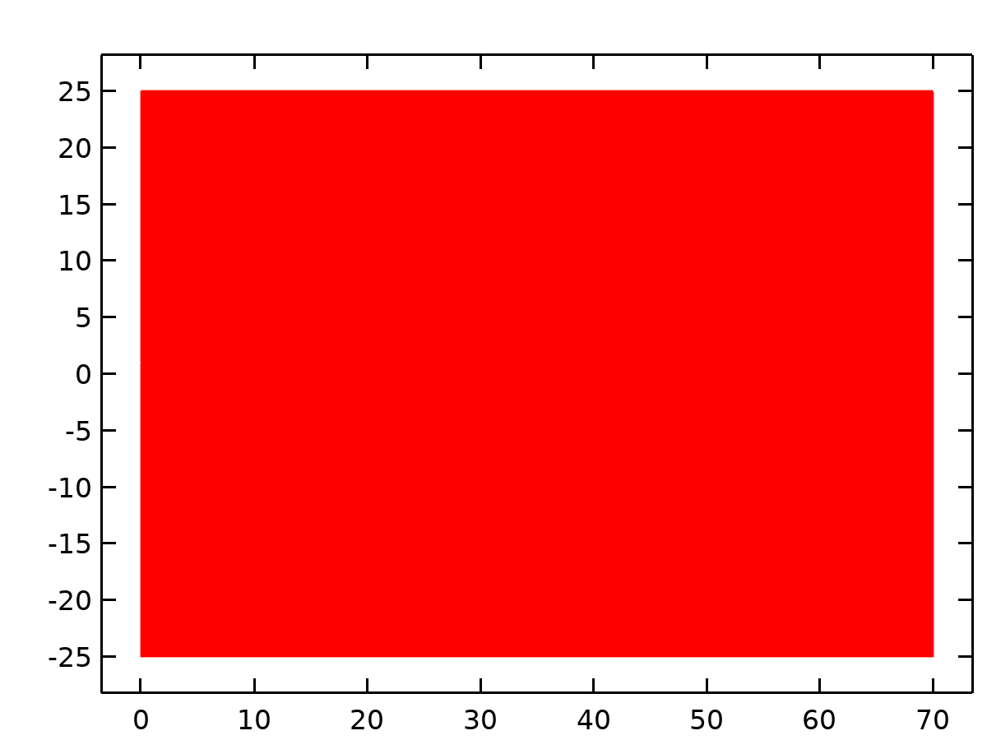

Dataset: Study 1/Solution 1

* + 1. Revolution 2D

Data

| **Description** | **Value** |
| --- | --- |
| Dataset | Study 1/Solution 1 |

Axis data

| **Description** | **Value** |
| --- | --- |
| Axis entry method | Two points |
| Points | {{0, 0}, {0, 1}} |

Revolution layers

| **Description** | **Value** |
| --- | --- |
| Start angle | -90 |
| Revolution angle | 225 |

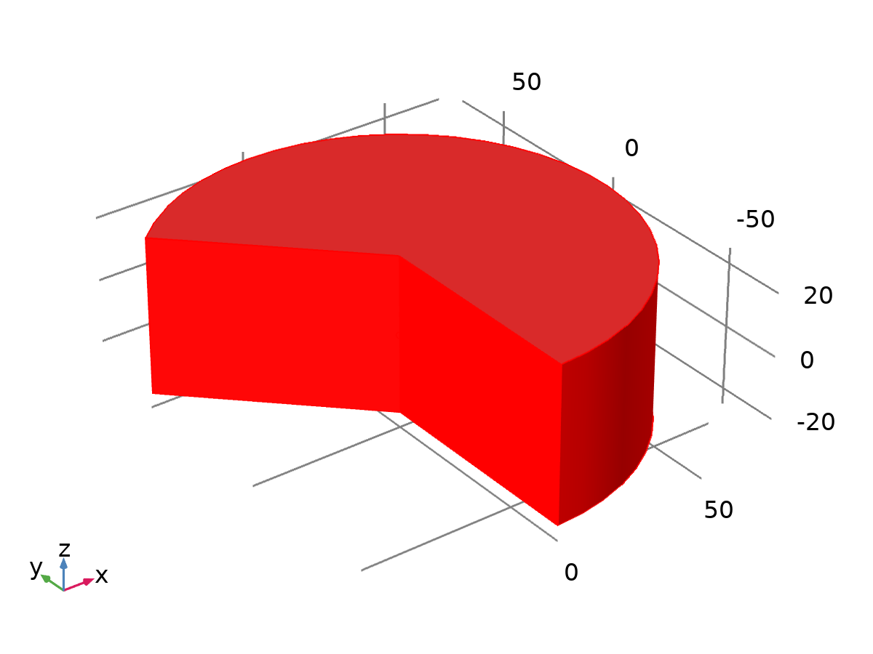

Dataset: Revolution 2D

* 1. Derived Values
     1. Line Integration 1

Data

| **Description** | **Value** |
| --- | --- |
| Dataset | Study 1/Solution 1 |

Expressions

| **Expression** | **Unit** | **Description** |
| --- | --- | --- |
| spf.T_stressphi |  | Total traction, exterior boundaries, phi component |
| spf.T_stressr |  | Total traction, exterior boundaries, r component |
| spf.T_stressz |  | Total traction, exterior boundaries, z component |
| -spf.T_stressz*2/(rhof*V^2*D) |  |  |

Integration settings

| **Description** | **Value** |
| --- | --- |
| Integration order | 4 |
| Compute surface integral | On |

* 1. Tables
     1. Re vs Drag Coefficient Table

| **Re** | **Drag Coefficient (CD)** |
| --- | --- |
| 0.10000 | 205.02 |
| 0.11000 | 185.20 |
| 0.12000 | 168.83 |
| 0.13000 | 155.09 |
| 0.14000 | 143.41 |
| 0.15000 | 133.36 |
| 0.16000 | 124.64 |
| 0.17000 | 117.01 |
| 0.18000 | 110.27 |
| 0.19000 | 104.28 |
| 0.20000 | 98.919 |
| 0.21000 | 94.101 |
| 0.22000 | 89.745 |
| 0.23000 | 85.789 |
| 0.24000 | 82.181 |
| 0.25000 | 78.876 |
| 0.26000 | 75.839 |
| 0.27000 | 73.038 |
| 0.28000 | 70.446 |
| 0.29000 | 68.041 |
| 0.30000 | 65.804 |
| 0.31000 | 63.717 |
| 0.32000 | 61.766 |
| 0.33000 | 59.937 |
| 0.34000 | 58.221 |
| 0.35000 | 56.606 |
| 0.36000 | 55.083 |
| 0.37000 | 53.646 |
| 0.38000 | 52.286 |
| 0.39000 | 50.998 |
| 0.40000 | 49.777 |
| 0.41000 | 48.617 |
| 0.42000 | 47.513 |
| 0.43000 | 46.462 |
| 0.44000 | 45.460 |
| 0.45000 | 44.503 |
| 0.46000 | 43.589 |
| 0.47000 | 42.714 |
| 0.48000 | 41.877 |
| 0.49000 | 41.074 |
| 0.50000 | 40.304 |
| 0.51000 | 39.565 |
| 0.52000 | 38.854 |
| 0.53000 | 38.171 |
| 0.54000 | 37.513 |
| 0.55000 | 36.880 |
| 0.56000 | 36.270 |
| 0.57000 | 35.681 |
| 0.58000 | 35.113 |
| 0.59000 | 34.564 |
| 0.60000 | 34.033 |
| 0.61000 | 33.521 |
| 0.62000 | 33.024 |
| 0.63000 | 32.544 |
| 0.64000 | 32.079 |
| 0.65000 | 31.628 |
| 0.66000 | 31.191 |
| 0.67000 | 30.767 |
| 0.68000 | 30.356 |
| 0.69000 | 29.957 |
| 0.70000 | 29.569 |
| 0.71000 | 29.192 |
| 0.72000 | 28.825 |
| 0.73000 | 28.469 |
| 0.74000 | 28.122 |
| 0.75000 | 27.785 |
| 0.76000 | 27.456 |
| 0.77000 | 27.136 |
| 0.78000 | 26.824 |
| 0.79000 | 26.520 |
| 0.80000 | 26.224 |
| 0.81000 | 25.935 |
| 0.82000 | 25.653 |
| 0.83000 | 25.377 |
| 0.84000 | 25.109 |
| 0.85000 | 24.846 |
| 0.86000 | 24.590 |
| 0.87000 | 24.339 |
| 0.88000 | 24.095 |
| 0.89000 | 23.855 |
| 0.90000 | 23.621 |
| 0.91000 | 23.392 |
| 0.92000 | 23.168 |
| 0.93000 | 22.949 |
| 0.94000 | 22.735 |
| 0.95000 | 22.525 |
| 0.96000 | 22.319 |
| 0.97000 | 22.117 |
| 0.98000 | 21.920 |
| 0.99000 | 21.726 |
| 1.0000 | 21.537 |

* 1. Plot Groups
     1. Velocity (spf)

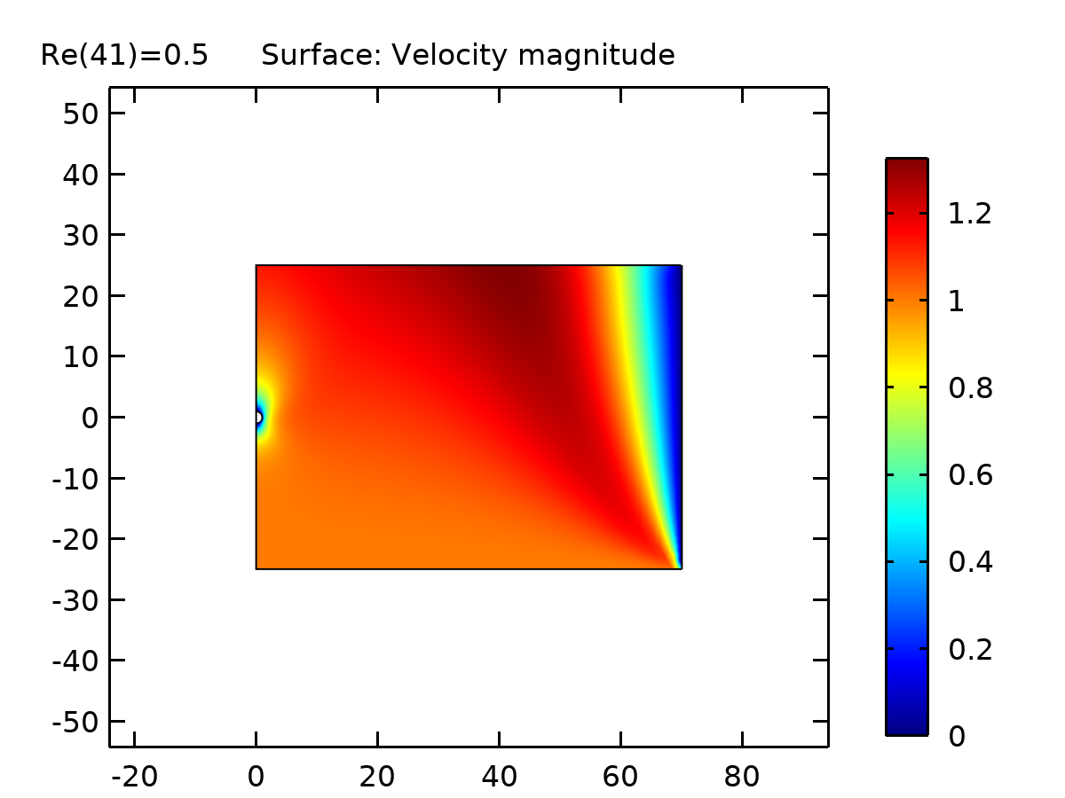

Surface: Velocity magnitude

* + 1. Pressure (spf)

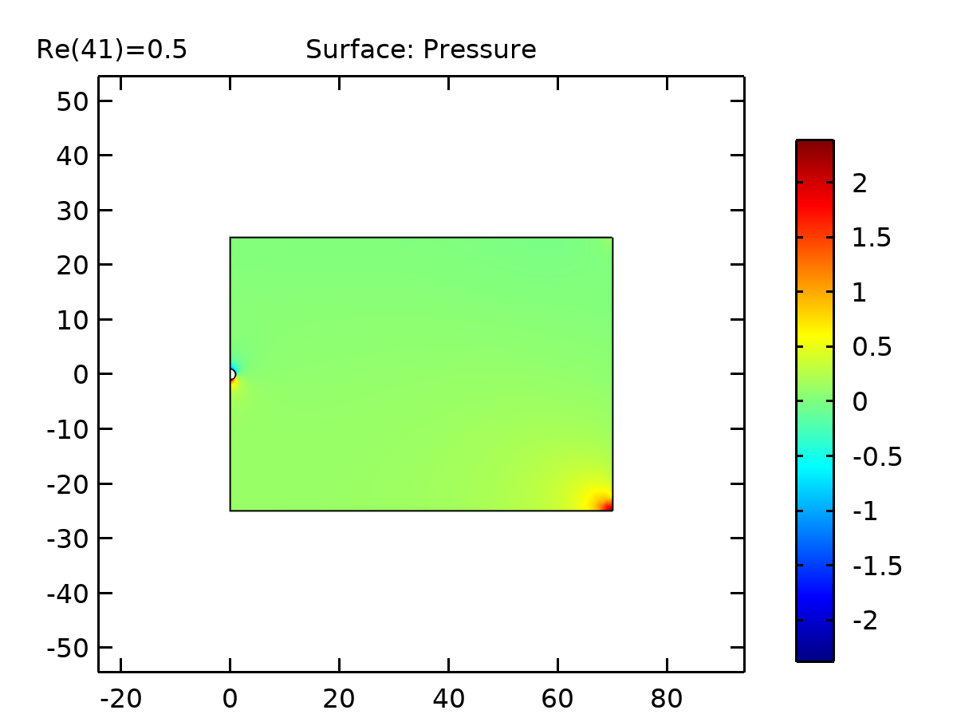

Surface: Pressure

* + 1. Velocity, 3D (spf)

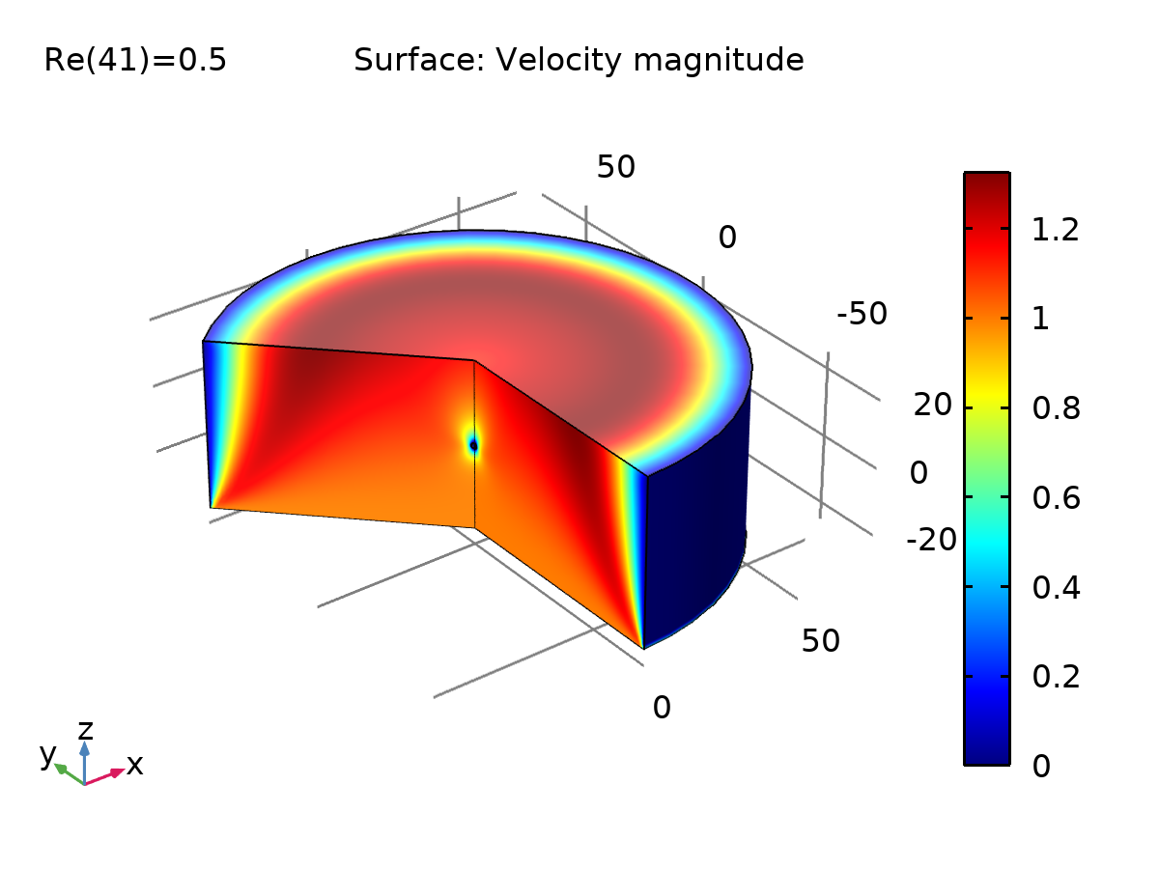

Surface: Velocity magnitude

* + 1. Drag Force vs Low Re

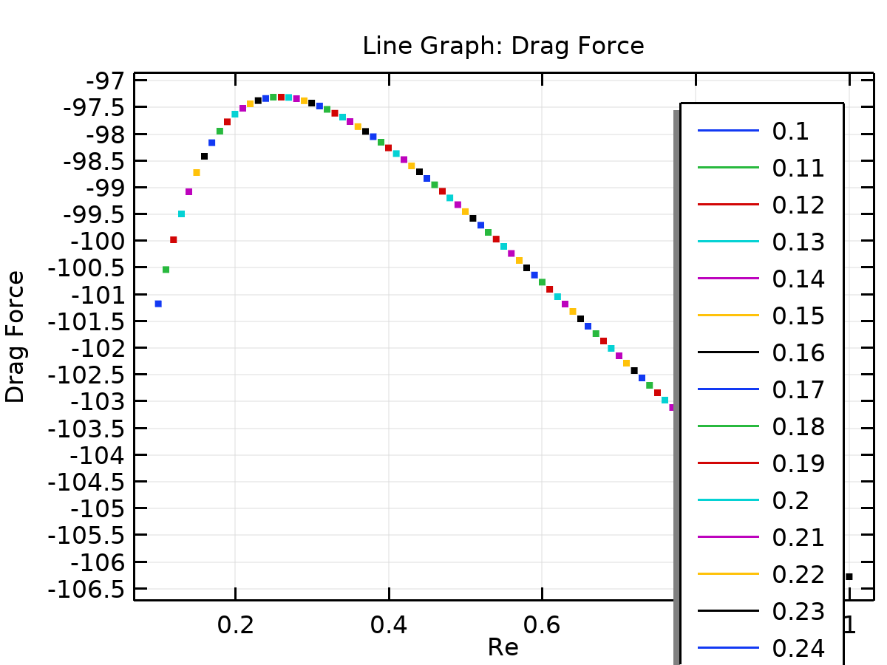

Line Graph: Drag Force

* + 1. Drag Coefficient (CD) vs Low Re

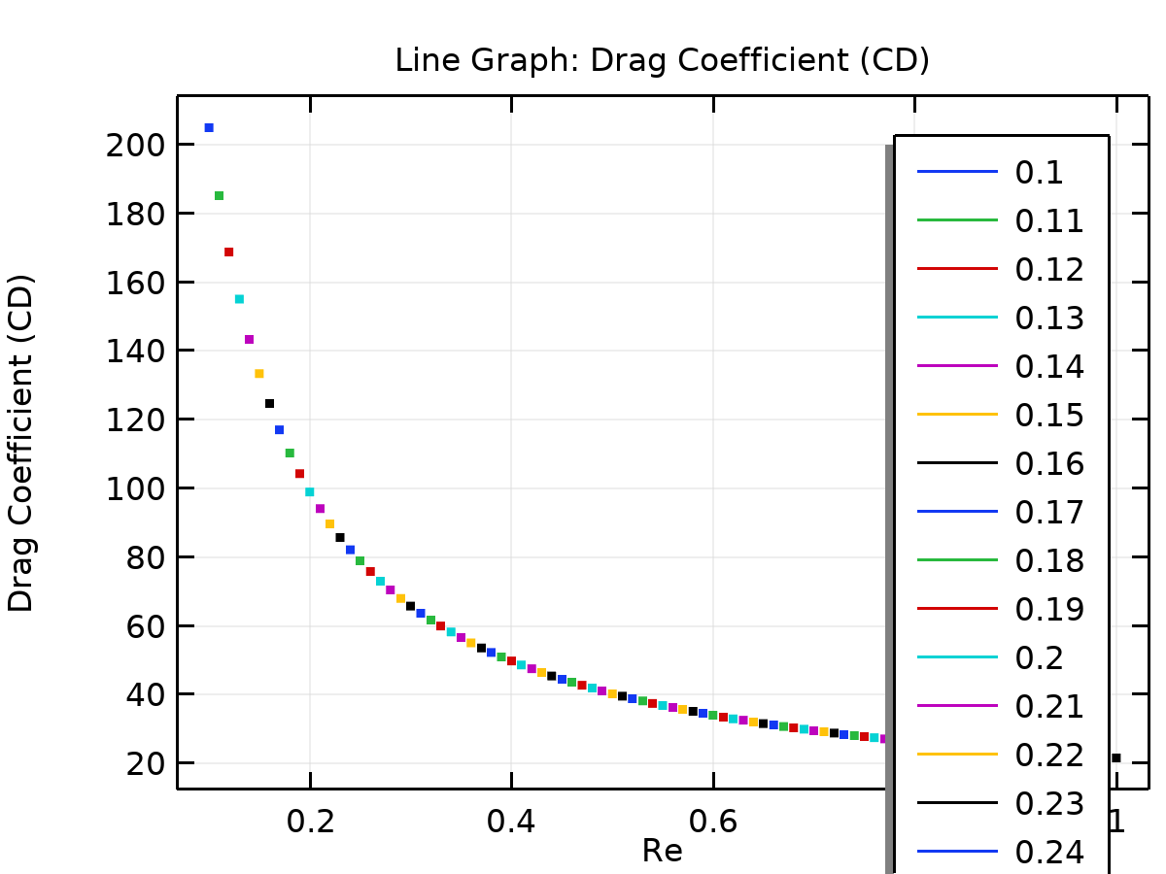

Line Graph: Drag Coefficient (CD)